**Table of Contents**

**Page**

**Title Page 1**

**Table of Contents 2**

**CHAPTER 1 CHAPTER AND ITS SETTINGS**

**Introduction 3**

**Background of the Study 4**

**Objectives of the Study 7**

**Scope and Limitation 7**

**Significance of the Study**

**CHAPTER 2 CONCEPTUAL FRAMEWORK**

**Review of Related Literature 9**

**Review of Related Studies 20**

**Conceptual Model of the Study 22**

**Operational Definition of Terms 24**

**CHAPTER 3 METHODOLOGIES**

**Project Design 25**

**Project Development 31**

**Operation and Testing Procedure 38**

**List of Tables**

**Table 1** Testing Procedures 46

**Table 2** Rating Scale for Evaluation Instrument 50

**Table 3** Numerical Range and its Qualitive Interpretation 51

**Table 4** Performance Efficiency Evaluation Result 62

**Table 5** Compatibility Evaluation Result 62

**Table 6** Usability Evaluation Result 63

**Table 7** Reliability Evaluation Result 64

**Table 8** Security Evaluation Result 64

**Table 9** Maintainability Evaluation Result 65

**Table 10** Portability Evaluation Result 66

**Table 11** Overall Percentage Frequency of Evaluation Result 66

**Table 12** Functional Suitability Evaluation Result 61

**List of Figures**

**Figure 1** Conceptual Model of the Study 32

**Figure 2** Context Level Diagram 35

**Figure 3.** Prenatal checkup process 36

**Figure 24.** Consultation process 38

**Figure 4.** Postnatal Process 39

**Figure 5.** Childbirth Process 39

**Figure 6.** Laboratory request process40

**Figure7.** Flowchart for the project development 41

**Figure8.** Use Case diagram of the proposed system 45

**Figure9.** Entity Relationship Diagram of the proposed system 46

**Figure 12** Login Page 55

**Figure 13** Side Navigation Bar 56

**Figure 14** Admin Dashboard 56

**Figure 15** Maternity Case List

**Figure 16** Creating new cases.

**Figure 17** Profiling

**Figure 20** Patient List

**Figure 21** Patient Profile

**Figure 22** Infant List

**Figure 23** Report

**Chapter I  
  
THE PROBLEM AND ITS SETTING**

This chapter contains the introduction, background of the study, objectives of the study, scope and delimitation, and significance of the study.  
  
**Introduction**

Maternity Clinic, also Lying-in Clinic, is an institution in the Philippines that provide excellent maternal services for pregnant women, newborn infants, and promoting reproductive health for the community. It offers maternal services including prenatal checkup, postnatal checkup, delivery or child birth, consultation, immunization, newborn screening, laboratory, and Family Planning. Maternity Clinic’s organization must be mainly composed of Midwives, Obstetrician, Gynecologist, and Pediatrician. Midwives, Obstetrician, and Gynecologist are responsible mostly to the maternal services for pregnant patients, while the Pediatrician is the one who manage the health of the child.   
  
 Maternity Clinics are under the Department of Health (DOH) and must secure necessary permits to operate. Some Midwives are affiliated to some associations like the Midwives Association of the Philippines (IMAP, Inc.). IMAP, Inc. was born on 1947 headed by Atty. Angelina C. Ponce where its main visions are to promote highest standards of midwifery practice, enhance the competence of members, reduce maternal and infant mortality, and sustain collaboration and partnership with related agencies.

**Background of the Study**

The Jewel’s First Maternity Clinic is located at 136 Block 8 Zone 2 Brgy. Fort Bonifacio, Taguig City. Its second branch is located at 131, Lot 8, Meralco road Upper Bicutan, Taguig City. It’s a private maternity facility that performs clinical and maternal duties to their patients for almost 8 years and founded by Mrs. Remedios A. Saludes, R.M.  
 This maternity clinic is still using the old process of paper system in their recording process. Using papers in recording patient’s information, checkup results, and transaction records, piles of records are stored in their respective filing cabinet. It causes a slow retrieval of files and sometimes misplacement of some records due to overloading of files in the filing cabinet. The process of generating of report, too, takes time because the staff-in-charge needs to retrieve a record and create a report using pen and papers. Patients can only know the availability of their desired appointment when they ask the in-charge midwife about it.

During the duration of pregnancy, a patient is required to undergo Prenatal Checkup to have a healthy pregnancy. In the first trimester, the patient must go through once or twice prenatal checkup. The succeeding five months will have at least three visits for prenatal checkups every month. The ninth month will be every week until the due date of pregnancy. Prenatal Checkup is mainly composed of Physical Examination and Medical History. Physical Examination is firstly done through measuring the height and weight of the patient to calculate the Body Mass Index (BMI). The BMI will determine the prescribed weight gain to be maintained while pregnant. Physical Examination is also consisting of measuring the blood pressure, heart and breathing rate. The midwife will conduct a complete physical evaluation especially in cervix, uterus, and vagina of the patient to have a confirmation about the stage of pregnancy.

On the other hand, Medical History examination is also important to have an assessment about the pregnancy history of the patient. The midwife will interview about the patient’s past pregnancies, if she had undergone childbirth, menstrual cycle, and gynecological history. The said patient will also be examined about her medical history, medications used, and her lifestyle. The patient must be honest and open about this to ensure a healthy pregnancy.

Recording process during the delivery of the patient starts by identifying the date and time of labor and delivery, patient’s information and type of delivery. During this time, the prenatal checkup results of the patient are essential for the midwives to have an early assessment about the maternal care. These checkup results will be the basis for a successful childbirth.

After a successful delivery, the following information of the newborn infant will be now recorded and stored in the filing cabinet. One of this is the Physical Examination to check for obvious signs or status of the newborn infant. After 24 hours, the Newborn Screening (NBS) will also be done to ensure that the infant is safe from Congenital Metabolic Disorder. Without Newborn Screening, an infant with Congenital Metabolic Disorder may lead to mental retardation or death if it is left untreated.

Postnatal Checkup will be scheduled six weeks after the patient’s childbirth. It is also called “Six-week check”. The midwife will make sure that the infant is growing healthy and the mother is recovering well from the operation. Postnatal Checkup is an important evaluation for both patients. It is important for the mother to discuss her physical, mental, and emotional state after the childbirth. It is also a chance for the patient and her partner to talk about to the midwife about the difficulties she experienced during the six weeks and other related things about her post pregnancy. On the other hand, the newborn infant will undergo physical examinations to check if all the organs are developing well. Immunization and vaccines are also included to ensure the health of the patient. Information about the newborn infant will be stored in a baby book which will be used in the following checkups.

The researchers recognized that there is a problem in the storage of the patients’ records and the generating of reports. The researchers believed that a dynamic Maternity Clinic Management System is needed to solve the problem.

The researchers aimed to develop a Maternity Clinic Management System which is expected to automate most of the transactions and clinical services of the clinic giving emphasis to management, retrieval, storage and the creation of reports of the patients’ records. It also gives emphasis between the improvement of communication and connection between the Jewel’s First Maternity Clinic and its valued patients.

**Objectives of the Study**

The general objective of the study is to develop a Maternity Clinic Management  
System. Specifically aims to:

1. Design the system with the following attributes:  
 a. patient record management system;  
 b. scheduling system;  
 c. online appointment;  
 d. report generator for medical records, prenatal and postnatal checkup results, and summary of maternity case.  
2. Create the system using Sublime Text as text editor, WAMP (Windows, Apache,  
 MySQL, and PHP: Hypertext Preprocessor), HTML (Hypertext Markup Language),   
 CSS (Cascading Style Sheet), and Adobe Photoshop CS6.

3. Test and improve the system in terms of functionality and usability.  
4. Determine the level of acceptability of the developed system using ISO 9126.

**Scope and Delimitation of the Study**

The study focuses on designing, development, testing, and improvement of a   
Maternity Clinic Management System for Jewel’s First Maternity Lying-in and Medical Clinic.The system provides the user an automated Patient Record Management System   
where the administrator can perform the prenatal and postnatal checkups, monitor patients who need immediate medical assistance, and create patient record reports.   
 In addition to this, patients who already have an account in the website can have access to online appointment. They can also view their personal information, growth chart, and previous checkup results.

Laboratory result, recording labor information of patients, and centralizing the database of two clinic branches are not included in the system.  
  
**Significance of the Study** This study that we will develop and deploy can help the Jewel’s First Maternity Lying-in and Medical Clinic on securing their clinical records and most importantly the processing of their everyday clinical tasks. It will be simplified and maximized time spent. This will result into better maternal services and boost the profit.

Additionally, this study will provide the patients a better service.

**CHAPTER II  
CONCEPTUAL FRAMEWORK**

This chapter presents the review of related literature and review of related studies. It also includes the conceptual model of the study and the operational definition of terms.  
**Review of Related Literature**

**Records Management System**

According to techopedia.com, a Record Management System is the management of records for an organization throughout the records-life cycle. The activities in this management include the systematic and efficient control of the creation, maintenance, and destruction of the records along with the business transactions associated with them.

Techopedia also explains the activities involved in records management. These are identifying first the information that is needed to be captured; this follows up the information planning and enforcement of policies and practices regarding creation, maintenance, and disposal of records. Next is the classification, identification, and storing the records. The last activity mentioned is the coordination of providing internal and external access to the records without forfeiting the data privacy and business and data confidentiality of the organization.

Furthermore, ricohdocs.com explained that the records management is basically the process of creating, maintaining, using, and disposing records in an organized way. This helps achieve transparent, accountable, and efficient governance. The records should be managed following the records management program of an organization that is governed by a certain policy.  
 In addition to this, wikipedia.org clarifies that the ISO 15489-1: 2001 standard (“ISO 15489-1: 2001”) defines record management as “the field of management responsible for the efficient and systematic control of the creation, receipt, maintenance, use and disposition of records, including the processes for capturing and maintaining evidence and information about business activities and transaction in the form of records.” **Maternity Clinic**

Wikipedia.org defines the maternity clinic as a clinic that specializes in maternal care. It is responsible of caring for women during and after pregnancy. It also provides care for newborn infants, facilities for childbirth, maternity checkups, and family planning. It may also act as centers for clinical training in midwifery and obstetrics.

A place where you can do regular check-ups that allow doctors and midwives to treat and prevent potential health issues throughout the way of the pregnancy while giving advice for healthy lifestyle that can give advantage both mother and child.

**Midwifery**

According to Wikipedia.org, Midwifery, as known as obstetrics, is a health science and health profession that deals with pregnancy, childbirth, newborn care, reproductive health and postpartum period.

Additionally, World Health Organization explains that midwifery encompasses care for women during pregnancy, labor, and until the postpartum period. It is also stated in who.int, World Health Organization’s website, that midwifery is also bound to newborn care. The main objectives are to prevent health problems in pregnancy, detection of abnormal conditions of both patients, and providing medical assistance when required.

Midwifery in the Philippines as a profession was relatively unknown until Dr. Jose Fabella founded the first school of midwifery in May 1992 – the Maternity and Children’s Hospital (now called Dr. Jose Fabella Memorial Hospital). According to the Integrated Midwives’ Association of the Philippines (IMAP, Inc.), Dr. Fabella led the midwifery to utilize in the Philippines by training the young women in midwifery to gradually supplant the unlicensed midwives. Midwifery became a course and continuously expanding in the country. Thereafter, the midwifery profession has reached a high standard and its activities have increased in a scope. This result into recognition that a dynamic midwives’ association must be created to serve, train, educate, and provide health service in the country. Integrated Midwives Association of the Philippines was created through this recognition on March 17, 1976.

**WAMP**

WAMP is an acronym for Windows, Apache, MySQL, and PHP. According to their website, wampserver.com, WAMPServer is a Windows web development environment. It allows the user to create web application with Apache2, PHP, and MySQL database. PhpMyAdmin is also included to manage the database easily.

**Windows Operating System** An article written by The Editors of Encyclopedia Britannica in britannica.com discussed the Windows OS. Windows was created by Microsoft Corporation to run on Personal Computers (PC). It features the first Graphical User Interface (GUI) for IBM-compatible PCs. Through the years since 1985, Microsoft’s Windows dominated in the market and approximately 90 percent of PCs run a version of Windows. Up until today, Windows expands its product creating more possibilities and innovation to its customers.

**Apache HTTP Server**

Apache HTTP Server is free and open-source cross-platform web server software. According to their website, httpd.apache.org, Apache HTTP Server Project aimed at creating a robust, commercial-grade, full of feature, and freely-available source code implementation of an HTTP (Web) Server.

**PHP**  
 An article in Wikipedia.org about scripting language discusses about PHP. PHP is a server-side scripting language that is designed primarily for web development; PHP also extends its usability in general-purpose programming language. It is originally created by Rasmus Lerdorf in 1994 and it stands for the recursive acronym for PHP: Hypertext Preprocessor. An addition from the article, a PHP code may be embedded into HTML or HTML5 markup, web frameworks, web content management systems, and web template systems.

**MySQL**

MySQL is an open-source relational database management system. It is created by a Swedish company named MySQL AB and founded by David Axmark, Allan Larsson and Michael “Monty” Widenius. MySQL’s name is a combination from Michael Widenius’ daughter “My”, and the abbreviation for Structured Query Language, “SQL”. MySQL’s first internal release was on May 23, 1995 and a Windows version was released on January 8, 1998. Continuous versions were released every year and in 2008, Sun Microsystems acquired MySQL AB. Shortly after 2 years, Oracle Corporation acquired Sun Microsystems in January 27, 2010.

**Cascading Style Sheet**

As stated in www.w3.org, CSS is responsible on insulating the script body to its display. This is specially made to give the author/creator a control outside of structure, particularly the text alignment, object position on the page, audio and speech output, font characteristics and tables. In addition, by using style sheets your project can be more accessible than usual.

In expanding the idea to the subject matter, CSS can be your reference by offering some features that can give a precise control on your project such as control on spacing, alignment and positioning. Authors/creators can avoid unexpected use of such tags. Relevance to the subject of issue about tags, the style sheet itself can also avoid and help on reduce image misuse.

Using style sheets can allow you to access the basic fundamentals of HTML like font size, color and style and also it can support automatically generated numbers, markers and other content that can help the authors to stay oriented within their document.

**Dataflow Diagram**

According to https://www.lucidchart.com/pages/data-flow-diagram, a data flow diagram (DFD) maps out the flow of information for any process or system. It uses defined symbols like rectangles, circles and arrows, plus short text labels, to show data inputs, outputs, storage points and the routes between each destination. Data flowcharts can range from simple, even hand-drawn process overviews, to in-depth, multi-level DFDs that dig progressively deeper into how the data is handled. They can be used to analyze an existing system or model a new one. Like all the best diagrams and charts, a DFD can often visually “say” things that would be hard to explain in words, and they work for both technical and nontechnical audiences, from developer to CEO. That’s why DFDs remain so popular after all these years. While they work well for data flow software and systems, they are less applicable nowadays to visualizing interactive, real-time or database-oriented software or systems.

A data flow diagram can dive into progressively more detail by using levels and layers, zeroing in on a particular piece.  DFD levels are numbered 0, 1 or 2, and occasionally go to even Level 3 or beyond. The necessary level of detail depends on the scope of what you are trying to accomplish.

* DFD Level 0 is also called a Context Diagram. It’s a basic overview of the whole system or process being analyzed or modeled. It’s designed to be an at-a-glance view, showing the system as a single high-level process, with its relationship to external entities. It should be easily understood by a wide audience, including stakeholders, business analysts, data analysts and developers.
* DFD Level 1 provides a more detailed breakout of pieces of the Context Level Diagram. You will highlight the main functions carried out by the system, as you break down the high-level process of the Context Diagram into its sub processes.
* DFD Level 2 then goes one step deeper into parts of Level 1. It may require more text to reach the necessary level of detail about the system’s functioning.
* Progression to Levels 3, 4 and beyond is possible, but going beyond Level 3 is uncommon. Doing so can create complexity that makes it difficult to communicate, compare or model effectively.

**CodeIgniter**

In a discussion presented by lynda.com, CodeIgniter is defined as an open-source PHP Web Application Framework that has rapid development, provides logical structure and reusable interface. CI also features a lightweight framework, fast performance, and a little configuration.

**AJAX**

AJAX is defined in segeutech.com as a client-side script that communicates to and fro a server/database asynchronously. AJAX stands for Asynchronous JavaScript and XML.

**jQuery**

According to technopedia.com, jQuery is a concise and fast JavaScript library thatn can be used to simplify handling. Techterms.com also defined jQuery as a JavaScript library that allows Web Developer to add extra functionality to their websites.

**ISO 9126 Software Quality Characteristics**

International Organization for Standardization 9126 is about evaluation of software. ISO 9126 is divided into 4 major parts: quality model, external metrics, internal metrics and quality in use metrics.

ISO 9126 also have 6 main quality characteristics, stated as the following: functionality, reliability, usability, efficiency, maintainability and portability.

Functionality defines the purpose of any product or service. It also stated that the more functions the software has the more it is become complicated.

For example, in creating structure design for a business, as usual, you listed all the things that are needed in order to create such a design. These listed things are the functions. Functions in functionality are expressed as totality of essential functions that the software product provides. The author stated that it is important to note that the presence or absence of these functions in software product are either define as existing or not same idea as yes or no.

Reliability means the capability of the system to maintain its operation under some pressures for example, if an existing system goes down for 20 seconds then comes back the system should be able to recover and continue functioning. This defines that reliability in a system must give a quality of performance with or without issues.

Usability is existing with regards to the functionality. Usability defines the usefulness of a system, the usefulness of its function to be particular. For example, ATM machine should dispense cash as requested, if the user request to withdraw i.e. $5000, the ATM should release $5000. This where the usability works with regards with functionality. If the system didn't work as expected therefore the usability does not exist.

Efficiency also works with functionality, but this one is different because it is concern with the system resources. With relevance to software product, efficiency is indicated by the amount of disk space, memory and network.

Maintainability in a sense of fixing the errors and maintaining its operation. The developers for example, in order to maintain their system's functions, they protected it by the means of code readability or complexity as well as modularization. Any concern that helps identifying the cause and fixing the errors is the main definition of maintainability in system product.

Portability this characteristic defines as how the software can adapt to its environment.

**Object Oriented Programming**

In reference to searchmicroservices.techtarget.com OOP defines organization around objects rather than functions and it prefer data rather than logic. In history, each program displayed as logical structure and proceeds with inserting data process it inside the program and produces an output data.

**Database Management System**

The usual definition of database based on my experience is that it is consist of data rows and columns with regards to the data inserted. It is also a collection of information that is organized so it means that it can easily accessed, managed and updated.

Database definition according to www.searchsqlserver.techtarget.com, that data is well-organized inside into rows, columns and tables. As stated, you can insert, update and edit each data table. Whenever a new data is added, the database or database table expanded as well as updated.

Based on <https://www.techopedia.com>, a database management system (DBMS) is a software package designed to define, manipulate, retrieve and manage data in a database. A DBMS generally manipulates the data itself, the data format, field names, record structure and file structure. It also defines rules to validate and manipulate this data. A DBMS relieves users of framing programs for data maintenance. Fourth-generation query languages, such as SQL, are used along with the DBMS package to interact with a database.

**Operating System**

"The operating system (OS) is the most important program that runs on a computer. Every general-purpose computer must have an operating system to run other programs and applications" - http://www.webopedia.com/TERM/O/operating_system.html

Operating system is the tree of each branches because you cannot use your computer as you are using it normally without a user-friendly OS. Also, you cannot run a software without a supporting Operating System because the system knows the compatibility of it. For a larger system, Computer Operating System does have more responsibilities that usual because of its different usability and functionality.

**Microsoft Office**

Microsoft office is consisting of Word, Excel, PowerPoint, Access, Publisher and Outlook. Each program has different purpose; it depends on the user on what program is needed. If you are creating some documents or resume to be particular, you have to use Microsoft Word. If you are a Financial Assistant, you can use Microsoft Excel because it has a function that can actually help with regards to computing. If you want to create a presentation, you can use Microsoft PowerPoint. If you are inspiring to create a program with inserting, updating and deleting data, you can use Microsoft Access as your database. You can create some designs with the help of Microsoft Publisher. Inside the office, the emails should be protected and private, you can use Microsoft Outlook as your program for sending email exclusively.

**Adobe Photoshop**

Photoshop is a software where you create some designs for your project, also it is use in editing photos. It is the most predominant photo editing software in the market because of its features that can actually help your project to become professionally-looked. Digital painting is also possible to create using Photoshop.

**System Development Life Cycle**

Systems development cycle is a conceptual model that can describe the stages involved in an information system. According to <http://searchsoftwarequality.techtarget.com>, SDLC is a useful conceptual model for project management because it’s the one that describes the stages involved in an information system development project, from an initial feasibility study through maintenance of the completed application.

In general, an SDLC methodology follows the following steps:

1. The existing system is evaluated. Deficiencies are identified. This can be done by interviewing users of the system and consulting with support personnel.
2. The new system requirements are defined. In particular, the deficiencies in the existing system must be addressed with specific proposals for improvement.
3. The proposed system is designed. Plans are laid out concerning the physical construction, hardware, operating systems, programming, communications, and security issues.
4. The new system is developed. The new components and programs must be obtained and installed. Users of the system must be trained in its use, and all aspects of performance must be tested. If necessary, adjustments must be made at this stage.
5. The system is put into use. This can be done in various ways. The new system can have phased in, according to application or location, and the old system gradually replaced. In some cases, it may be more cost-effective to shut down the old system and implement the new system all at once.
6. Once the new system is up and running for a while, it should be exhaustively evaluated. Maintenance must be kept up rigorously at all times. Users of the system should be kept up-to-date concerning the latest modifications and procedures.

# Entity Relationship Diagram

As stated by <https://www.smartdraw.com>, an entity relationship diagram (ERD) shows the relationships of entity sets stored in a database. An entity in this context is a component of data. In other words, ER diagrams illustrate the logical structure of databases.

At first glance an entity relationship diagram looks very much like a [flowchart](https://www.smartdraw.com/flowchart/). It is the specialized symbols, and the meanings of those symbols, that make it unique.

According to <https://www.webopedia.com>, an entity relationship model, also called an entity-relationship (ER) diagram, is a graphical representation of entities and their relationships to each other, typically used in computing in regard to the organization of [data](http://www.webopedia.com/TERM/D/data.html) within [databases](http://www.webopedia.com/TERM/D/database.html) or information systems. An entity is a piece of data-an [object](http://www.webopedia.com/TERM/O/object.html)or concept about which data is stored.

Relationships between Entities

A relationship is how the data is shared between entities. There are three types of relationships between entities:

## 1. One-to-One

One instance of an entity (A) is associated with one other instance of another entity (B). For example, in a database of employees, each employee name (A) is associated with only one social security number (B)

## 2. One-to-Many

One instance of an entity (A) is associated with zero, one or many instances of another entity (B), but for one instance of entity B there is only one instance of entity A. For example, for a company with all employees working in one building, the building name (A) is associated with many different employees (B), but those employees all share the same singular association with entity A.

## 3. Many-to-Many

One instance of an entity (A) is associated with one, zero or many instances of another entity (B), and one instance of entity B is associated with one, zero or many instances of entity A. For example, for a company in which all of its employees work on multiple projects, each instance of an employee (A) is associated with many instances of a project (B), and at the same time, each instance of a project (B) has multiple employees (A) associated with it.

# Data

According to <https://www.computerhope.com>, In general, **data** is any set of [characters](https://www.computerhope.com/jargon/c/charact.htm) that has been gathered and translated for some purpose, usually analysis. It can be any character, including text and numbers, pictures, sound, or video. If data is not put into context, it doesn't do anything to a human or computer.

Within a computer's storage, data is a collection of numbers represented as [bytes](https://www.computerhope.com/jargon/b/byte.htm) that are in turn composed of [bits](https://www.computerhope.com/jargon/b/bit.htm) ([binary digits](https://www.computerhope.com/jargon/b/binary.htm)) that can have the value one or zero. Data is processed by the [CPU](https://www.computerhope.com/jargon/c/cpu.htm), which uses [logical](https://www.computerhope.com/jargon/l/logic.htm) operations to produce new data ([output](https://www.computerhope.com/jargon/o/output.htm)) from source data ([input](https://www.computerhope.com/jargon/i/input.htm)).

As stated in <http://searchdatamanagement.techtarget.com>, in computing, data is [information](http://searchsqlserver.techtarget.com/definition/information) that has been translated into a form that is efficient for movement or processing. Relative to today's [computers](http://searchwinit.techtarget.com/definition/computer) and transmission media, data is information converted into [binary](http://searchcio-midmarket.techtarget.com/definition/binary) [digital](http://searchcio-midmarket.techtarget.com/definition/digital) form. It is acceptable for data to be used as a singular subject or a plural subject. [Raw data](http://searchdatamanagement.techtarget.com/definition/raw-data) is a term used to describe data in its most basic digital format.

# Information System

According to, https://www.study.com, many organizations work with large amounts of **data**. Data are basic values or facts and are organized in a **database**. Many people think of data as synonymous with **information**; however, information consist of data that has been organized to help answers questions and to solve problems.

As stated in bus206.pressbook.com, Information System (IS) is the study of complementary network of hardware and software that people, and organizations use to collect, filter, process, create, and distribute data. Additionally, Information systems are combinations of hardware, software, and telecommunications networks that people build and use to collect, create, and distribute useful data, typically in organizational settings. Furthermore, Information systems are interrelated components working together to collect, process, store, and disseminate information to support decision making, coordination, control, analysis, and visualization in an organization.

# Web Development

# According to <https://www.techopedia.com>, Web development broadly refers to the tasks associated with developing websites for hosting via intranet or internet. The web development process includes web design, web content development, client-side/server-side scripting and network security configuration, among other tasks.

In relating to the subject matter stated by <https://www.upwork.com>, Web development is the process of developing websites or webpages hosted on the Internet or intranet. Think about your favorite website; whether it’s an e-commerce store, blog, social network, online video streaming service, or any other type of Internet application, it all had to be built by a web developer.

# Use Case Diagram

According to [whatis.techtarget.com](http://whatis.techtarget.com)**,** use case diagram is a graphic depiction of the interactions among the elements of a system.

A [use case](http://searchsoftwarequality.techtarget.com/definition/use-case) is a methodology used in system analysis to identify, clarify, and organize system requirements. In this context, the term "system" refers to something being developed or operated, such as a mail-order product sales and service [Web site](http://searchsoa.techtarget.com/definition/Web-site). Use case diagrams are employed in [UML](http://searchsoftwarequality.techtarget.com/definition/Unified-Modeling-Language) (Unified Modeling Language), a standard notation for the modeling of real-world objects and systems.

System objectives can include planning overall requirements, validating a [hardware](http://searchcio-midmarket.techtarget.com/definition/hardware) design, testing and [debugging](http://searchsoftwarequality.techtarget.com/definition/debugging) a [software](http://searchsoa.techtarget.com/definition/software) product under development, creating an online help reference, or performing a consumer-service-oriented task. For example, use cases in a product sales environment would include item ordering, catalog updating, payment processing, and customer relations. A use case diagram contains four components. (1) The boundary, which defines the system of interest in relation to the world around it, (2) The actors, usually individuals involved with the system defined according to their roles, (3) The use cases, which the specific roles are played by the actors within and around the system, (4) The relationships between and among the actors and the use case.  
 As stated by [www.visual-paradigm.com](https://www.visual-paradigm.com), a [UML](https://en.wikipedia.org/wiki/Unified_Modeling_Language) use case diagram is the primary form of system/software requirements for a new software program under developed. Use cases specify the expected behavior (what), and not the exact method of making it happen (how). Use cases once specified can be denoted both textual and visual representation (such as UML). A key concept of use case modeling is that it helps us design a system from end user's perspective. It is an effective technique for communicating system behavior in the user's terms by specifying all externally visible system behavior. A use case diagram does not show the detail of the use cases, it only summarizes some of the relationships between use cases, actors, and systems, and it does not show the order in which steps are performed to achieve the goals of each use case.

# Review of Related Studies

Mitrais Medical System have 6 major modules, and these are the following: Patient Administration System, Clinical Information System, Accounting System, Pharmacy Information System, Ancillary Modules and Executive Information System. The system's area of work is to improve patient care and operational efficiency of the hospital. With a wide work of operational-based kind of system, it can be a way to dramatically improve the services particularly on patient's information system, technically, patient's profile will become more secure and safe with the help of system's major modules. According to the author itself, MMS is designed around best practice in patient care and supporting clinical and non-clinical services and automate all core hospital processes. By establishing electronic medical records and providing diagnostic supports with computerized physician order entry, MMS enables a hospital to quickly implement an effective solution to problems associated with proper patient identification, accuracy of diagnosis, drug management and pharmacy processes that support patient safety.

The Tata Memorial Hospital was initially commissioned by the Dorabji Tata as a center with enduring value and a mission for concern for sick people. In line with recent advances in Information Technology, the Tata Memorial Centre has established a comprehensive computerization of Medical Records, Material Management and Administration and also improved communication by widening of the Electronic mail and Internet facilities. The said studies prove that making Information Management will result more efficient and effective system within the Hospital. All information has been gathered through research, facts, and findings components. Some problems occurred such as human errors in recording and calculating different task or activities that will cost delay in the flow of work. TMH helps to evaluate our project with the certain similarities such as speeding up the daily activities and increase productivity of the stuffs.

Athena™ Maternity Information System provides an electronic patient note system spanning the whole of pregnancy. Electronic patient note or EPN is the dot for the term Electronic patient record because EPN emphasize that our new approach should put the clinician-patient interaction first and foremost from which all the benefits of the captured electronic information will naturally flow. EPN enables the following to flow naturally, first is accuracy. Accuracy in terms of being accurate of every clinician in clinical record because they knew the importance of each clinical record for each patient. Clarification, there will be no duplication of record because EPN will act as a replacement for handwritten note, there will be no handouts of any patient record unless someone in the position requested a print-out of it. Clinical record is the only record and it will be respected and treated as a confidential information just like the former handwritten note. Second is compliance and completeness, this one is a process with a mandatory charge when a patient is giving their data, there will be a full data entry compliance and all relevant information should be completed. Some benefits given provided by the system, first one is removal of paper. No more paper, handouts and anything related with paper records and etc. The pain of handwritten record is removed. When a particular record of was requested, the hospital will provide a print-out of it. These print-outs are copies of the EPN. “Entered Once, Used many Times”, this second benefit indicates that the full data given by the patient could possibly be involved in every hospital’s automated processes. These data are going through the hospital’s data flow with respect of relevance. Athena™ Maternity Information System provides top-level of services when it comes on securing and gathering data, producing some new specifications in automated processes particularly in setting patient’s data as a flexible data and lastly the electronic patient notes or EPN that acts as a new approach between clinician and patient when it comes on highlighting the benefits of the captured electronic information and actually used it under hospital’s data flow.

eHospital Systems is the healthcare ERP software that allows the hospital management to upgrade their management system and improve their services and manage all aspects of a hospital operation. This customizable hospital information system is an integrated healthcare solution which includes OPD and IPD Management, Pharmacy, Laboratory, Radiology, Ward Management, Mobile Application, Online Appointments Scheduling, Secure Messaging, Doctor Portal, Patient and Family Portals, Medical Electronic Billing, Accounting, HR/Payroll and HL7/Integrated PACS System. Traditional approaches encompass paper-based information processing as well as resident work position and mobile data acquisition and presentation. The customizable alert system sends the text or email and improves the quality of patient care. Electronic medical record (EMR Systems) helps to be aware of revenue stream, patient records and other key metrics at your fingertips. Electronic health record (EHR Systems) allows electronic sharing of patient records with other providers and medical applications and manage the overall health of patients such as Patient and Providers can see lab results and history online, securely chat with providers, and schedule next appointment. It is developed in India and USA based on the best practices around the world.

**Conceptual Model of the Study**

On the basis of the foregoing concepts, theories and findings or related literature, studies presented and insights taken from them, the conceptual model of the study was developed as shown below.

OUTPUT

Maternity Clinic Management System

PROCESS

System Design

System Development

System Testing

INPUT

Knowledge Requirements

* Maternity Clinic
* Patient Record Management System
* Database Management System
* Dataflow Diagram
* Entity Relationship Diagram
* ISO 9126
* PHP
* HTML
* CSS

Software Requirements

* WAMP
* Photoshop
* Sublime Text

Hardware Requirements

* Computer Unit
  + 2GB RAM
  + 500GB Hard Disk
  + Intel® Atom ™CPU N2600

EVALUATION

**Figure 1.** Conceptual Model of the Study.

Figure 1 is consists of Input, Process, and Output. The Input block is composed of knowledge, software, and hardware requirements that are needed for the completion of the system. The Process block is composed of System Design, System Development, and System Testing. On completion of these tasks, Output block represents the ‘Web-based Maternity Clinic Management System’ for Jewel’s First Maternity Clinic. **INPUT**

The input part of the IPO model comprises of three parts: Knowledge, Software and Hardware Requirements. In the development of the study, the following knowledge requirements were necessary: Maternity Clinic; Patient Record Management System; Database Management System; Dataflow Diagram; ISO 9126; PHP; HTML; and CSS. The software requirements of the system are necessary: Sublime Text; MySQL; Adobe Photoshop; and WAMP. The minimum hardware requirement that is needed for the system are as follow: 2GB RAM; 400GB Hard Disk; Intel® Atom ™CPU N2600.

**PROCESS**

The process part consists of the System Design, System Development, and System Testing. The first phase in the development of the study is the Project Design where it is compose of planning, gathering data, and analyzing the data gathered. Next phase will be the Project Development where the writing of codes for the system will be written. The third phase for the development of this study will be the System Testing. This is the actual testing and debugging of the system. The last phase is the Evaluation; it is the phase where the system will be evaluated in different categories by selected assessors to improve the quality of the system

**OUTPUT**

The final output of the study is the Maternity Clinic Management System for Jewel’s First Maternity Clinic.

**Operation and Definition of Terms**

**Maternity Clinic**

It is defined as an entity that provides maternal care and services to pregnant patients and newborn infants. It offers prenatal and postnatal checkup, childbirth, laboratory, family planning, and infant care.

**BMI**

A value derived from the mass and height of an individual. It is calculated by dividing the weight in kilogram to height in meters squared.

BMI = weight (kg) / (height^2)(m^2)

**Newborn Screening**

Is a practice of testing a blood sample from a newborn infant to find out if the newborn infant has a Congenital Metabolic Disorder. It is done after 24 hours after birth.

**CHAPTER III  
METHODOLOGY**

This chapter contains the project design, project development, and operation and testing procedure.

**Project Design** The project design is meant to describe the representation of the developed system in terms of its flow, entities, and existing relationship. Discussed below are the Data Flow Diagram, Visual Table of Contents, and Entity Relationship Diagram.

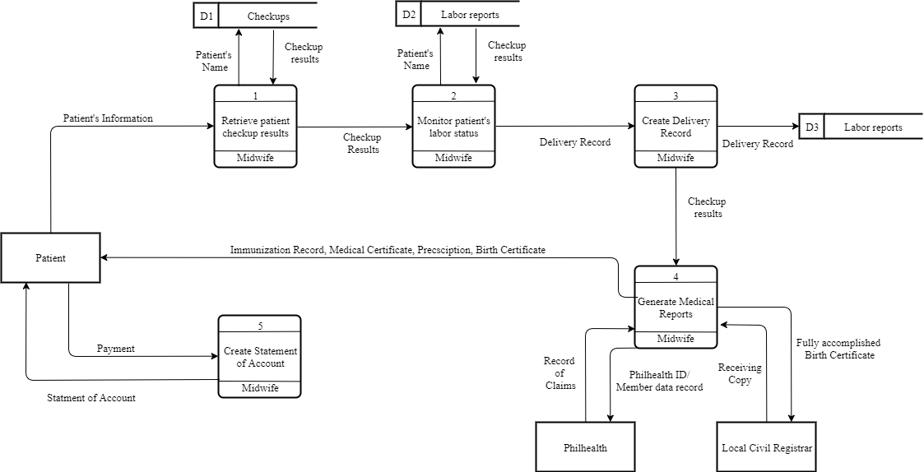

**Figure2**. Context Level Diagram

Figure 2 presents the context level diagram of the existing system of Jewel’s First Maternity Clinic. Patient’s records are sent to the manual pen-and-paper system and it will be stored in a file cabinet. Laboratory samples are sent in an external entity and it will receive the laboratory result. PhilHealth and Local Civil Registrar receive data about the pregnant and infant patients.

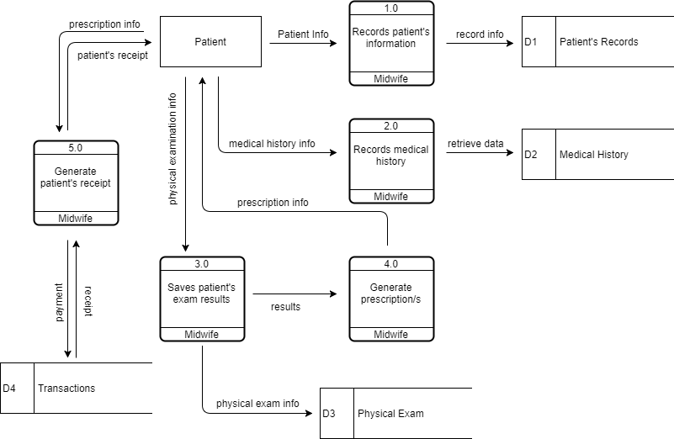

**Figure 3.** Prenatal checkup process

Figure 3 shows the prenatal process of old and new patients. New patients will undergo profiling before recording the medical history, physical examination, and to be followed by the prescription and receipt from the clinic. Additionally, the patients will pay the checkup fee.

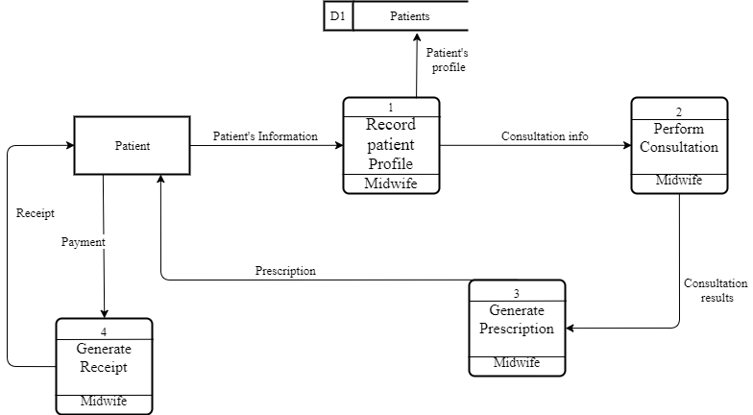

**Figure 24.** Consultation process

Figure 24 shows the process of the infant during the consultation process. Clinic’s midwife will retrieve the data of patient in their medical records. After checking patient’s info, consultation process performs. Before generating prescription for patient, consultation results are needed because of data dependency. After receiving the prescription given by the clinic, patent will undergo payment-receipt process.

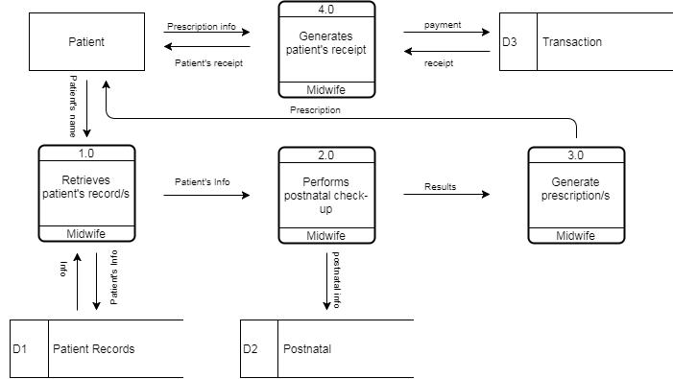

**Figure 4.** Postnatal Process

At the end of the quarter of being pregnant the next process is postnatal. Patient’s record will be checked again, if the data exist, midwife will perform postnatal check-up to the patient. Before generating prescriptions, check-up results are needed because of data dependency. Patient receives the prescription and payment-receipt process happens.



**Figure 5.** Childbirth Process

After getting pregnant, childbirth process occurs. First again, patient’s record will be retrieve by midwife in their medical records, next, midwife will perform monitoring on patient’s labor status. Delivery record will be created depends on patient’s labor status. Clinic’s midwife will receive check-up results of their patient and medical reports will be generated. Immunization record, medical record, prescription and birth certificate of patient’s child will be given to clinic’s patient.

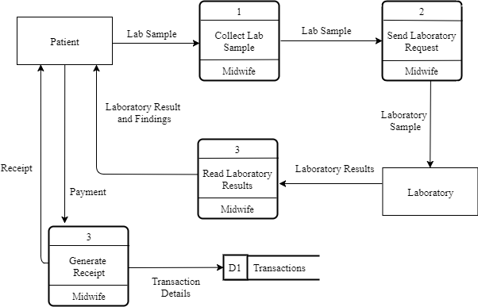

**Figure 6.** Laboratory request process

Laboratory request process is a clinical process wherein the patient will undergo some experiments, getting blood platelets and blood pressure. Midwife will collect the patient’s lab sample and will send laboratory request. After examining patient’s lab sample, laboratory will produce results and clinic’s midwife will present it to their patient. Payment-receipt process will be happened after receiving laboratory results.

**Project Development**  
 For the project development, the researchers have decided to use the waterfall method from the System Development Life Cycle (SDLC). Figure 8 shows the detailed flowchart of waterfall method.

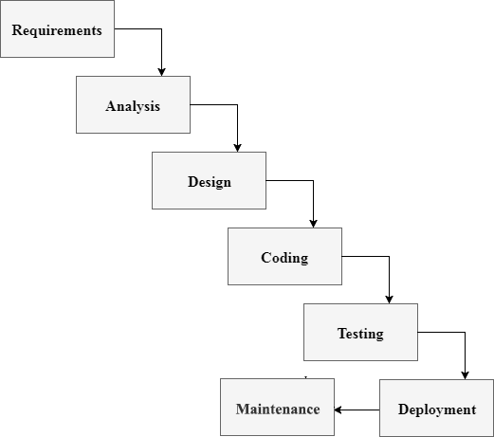

**Figure7.** Flowchart for the project development

1. Requirements

Gathering data from a client in development process would help the system to reach its desired functionality. Therefore, every system development comes to this, data requirements. In this phase, every data required are gathered as functional and non-functional requirements. It is important because of system’s modules dependency to its client’s information. This will be the basis of input and output process of the system. In clinic patient’s management, data are gathered as planned in order to manipulate the modules inside the system. As the data are given for system’s module as follows; patient record management system, clinic item monitoring system, scheduling system, online appointment, billing system and report generator for medical records, prenatal and postnatal check-up results.

2. Analysis

Analysis is detailed examination of the elements or structure of something, typically as a basis for discussion or interpretation. Most of organizations use business process automation to improve workflow and end-to-end business process. This type of strategy begins with an actual analysis of a “physical process” or manual process inside the organization in which the services are done or given. As a dependent phase, it will rely on what is present and dramatically improve the processes by proposing some improvements in order to provide satisfying services. A new technology alone is not enough to say that it is a project success but also endorsing the improvements of business processes inside the organization in such a way that users trust the system and find it easy enough to use. As related in systems analysis, clients will give information about their manual processes and eventually offers automation corresponds to their concern. This will help to provide such services in order to reach their goals in a way that technology is involved.

3. Design

In this phase the system and software design is prepared from the requirements specifications which is studied and gathered in the first phase. The system design specifications serve as input for the next phase of the model. In every system development this phase is important because of its functionality and usefulness in creating a system. Data flow diagram (DFD) is a type of business process in which the data is flowing. Inside of it are high level diagram and low-level diagram. These processes are shown inside the DFD in where the data gathered are designed as data flows. With relying on client’s data, database designs are created. Database are consisting of multiple of tables wherein the input and output process began. Also, the tables are the container of input data. Without it, the data flow and database design will crash.

4.Coding  
 In this phase as receiving the system design documents, the work of dividing it into modules and actual coding is started. Since, in this phase the code is produced so it is the main focus for the developer. This is the longest phase of software development cycle. Coding phase is the creation of the system itself with a dependency in system designs and information. If the design is performed in detailed and organized manner, code generation can be accomplished without much hassle. Every organization has way in using programming languages to develop a system. The programming language is chosen with respect to the type of software being developed.

5. Testing  
 In this phase the testing of the developed system happens. Quality assurance is important to give a feedback to a developer on which and where the errors occurs. Also, in this phase the communication between the Quality Assurance and Developer becomes more compact because of the improvement of the system that they’re working on. Testing a developed system before it is getting deployed is important in an organization because it is showing the needed improvements before the deployment phase.

6. Deployment

The deployment phase is the moment that the system is get tested and ready to be deployed. User Acceptance Testing (UAT) is talking about the deployment of the system in an organization wherein the improvements and debugging are still occurring because of the users’ suggestions and needs. These suggestions are reported directly into the developer team to update all the necessary concerns that the user is concern for. After the beta testing the actual deployment of the developed system in the market will happens after all the needed and mandatory testing are done.

7. Maintenance

Making sure that the application/software is up and running in the respective environment is talking about maintenance. Maintenance is the last phase wherein the system is already deployed and then the actual problems comes up and need to be solved from time to time. Every organization must still have a communication to their client in order to solve each problem and any other concern in their product. This process where the care is taken for the developed product is known as maintenance.

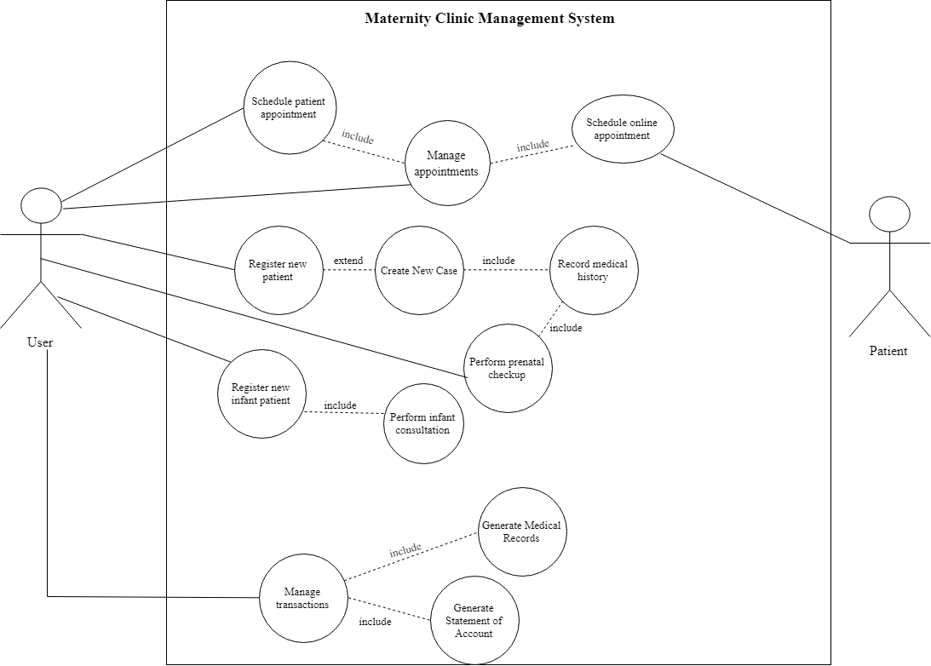**Use Case Diagram**

**Figure8.** Use Case diagram of the proposed system

**Database**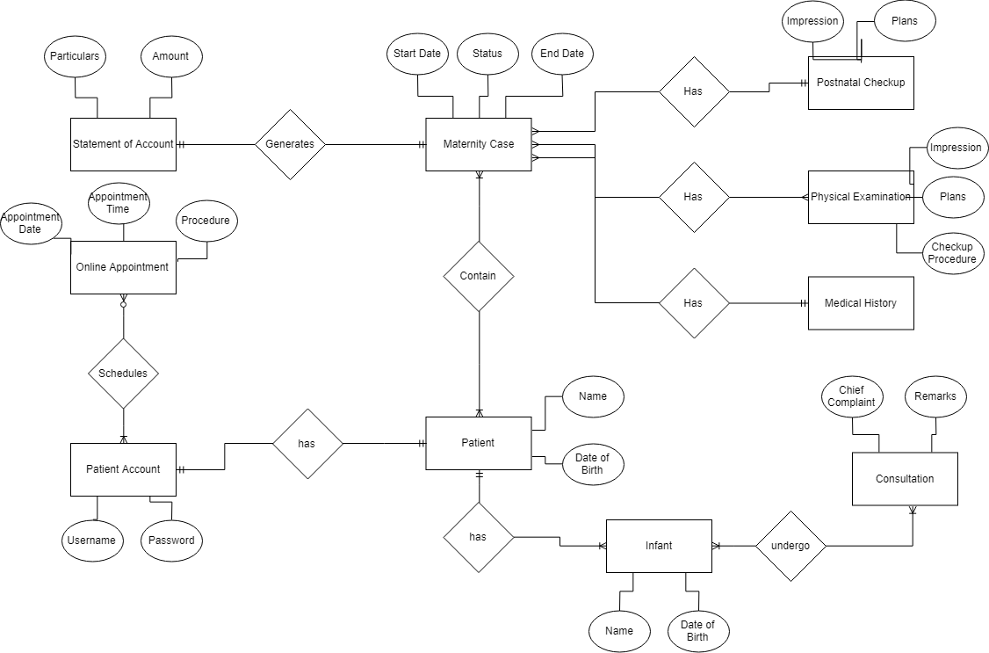

**Figure9.** Entity Relationship Diagram of the proposed system

**Operation and Testing Procedure** For the operation and testing of the system, the following steps will be conducted by the researchers.

**Table 1**Testing Procedures

|  |  |
| --- | --- |
| Modules | Steps Undertaken |
| Patient record management module | 1. Click “Add New Case”  2. Select “New Patient”  3. Populate required fields for profiling  4. Submit form and proceed to Medical History  5. Populate required fields for Medical History  6. Submit form and proceed to Physical Examination  7. Submit form |
| Patient profiles module | 1. Click “Patients” in the navigation bar  2. Search patient’s name in the search bar  3. Click “View Profile” |
| Scheduling module | 1. Click “Schedule” in the navigation bar  2. Click “Add new schedule” button  3. populate the required fields  4. select the available time and date  5. submit the form |
| Online appointment module | 1. Click “Schedule an appointment” button in the website  2. Populate the required fields  3. Select available time and date  4. Enter the Verification Code that will be sent through SMS  5. Enter the verification code in the text box |
| Medical report module | 1. Click “Reports” in the navigation bar  2. Search the name of the patient and click “Create medical report” button  3. A modal will appear and click “Prenatal checkup results” button |
|  |  |

Table 1 shows the series of procedures taken during the testing procedure. Each module of the system undergoes through a series of steps.

**Evaluation System**  
 The respondent’s profile, evaluation instrument used, rating scheme, and statistical test used are discussed in this section.  
 The system was purposively designed for “Jewels’ First Maternity Lying-in and Medical Clinic” specifically to the midwives who is responsible in record keeping. Forty-five (45) respondents tested and evaluated the system.

**Table 2.**  
 Rating Scale for Evaluation Instrument

|  |  |
| --- | --- |
| Numerical Rating | Descriptive Rating |
| 4 3 2 1 | Highly Acceptable Very Acceptable Acceptable Not Acceptable |

As shown in Table 1, the indicators were rated from the scale of 1 to 4 with 1 being the lowest or “Not Acceptable” and 4 as the highest or “Highly Acceptable”.

**Table 3.** Numerical Range and its Qualitative Interpretation

|  |  |
| --- | --- |
| Numerical Rating | Qualitative Interpretation |
| 3.4-40 2.6-3.3 1.8-2.5 1.0-1.7 | Highly Acceptable Very Acceptable Acceptable Not Acceptable |

Table 2 shows the Likert Scale used to interpret the results of evaluation, where the range of 3.4 – 4.0 is highly acceptable, 2.6 - 3.3 as very acceptable, 1.8 – 2.5 as acceptable, and 1.0 – 1.7 as not acceptable.

**Chapter IV  
Results and Discussion**

This chapter discusses the project description, project structure, project capabilities and limitations, and project evaluation.  
**Project Description** The Maternity Clinic Management System has the features created to…  
 The system was created using Sublime Text Editor, WAMP server, MySQL server, cascading style sheet, and hypertext markup language.

**Project Structure  
 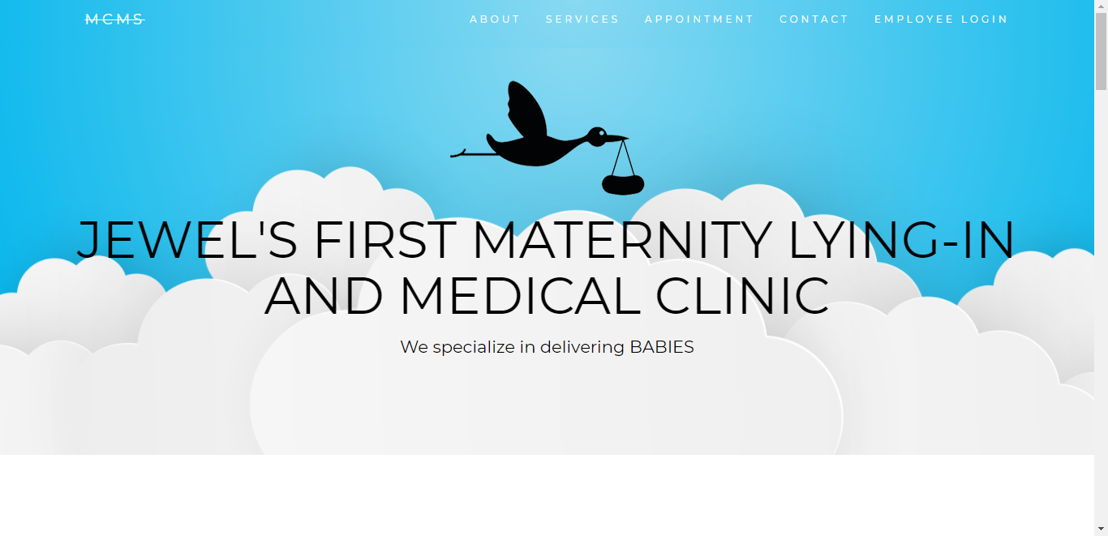**

**Figure 10.1** MCMS Website

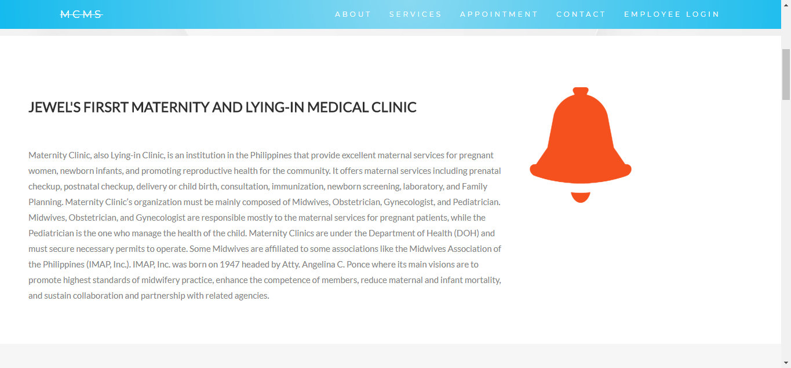

**Figure 10.2**

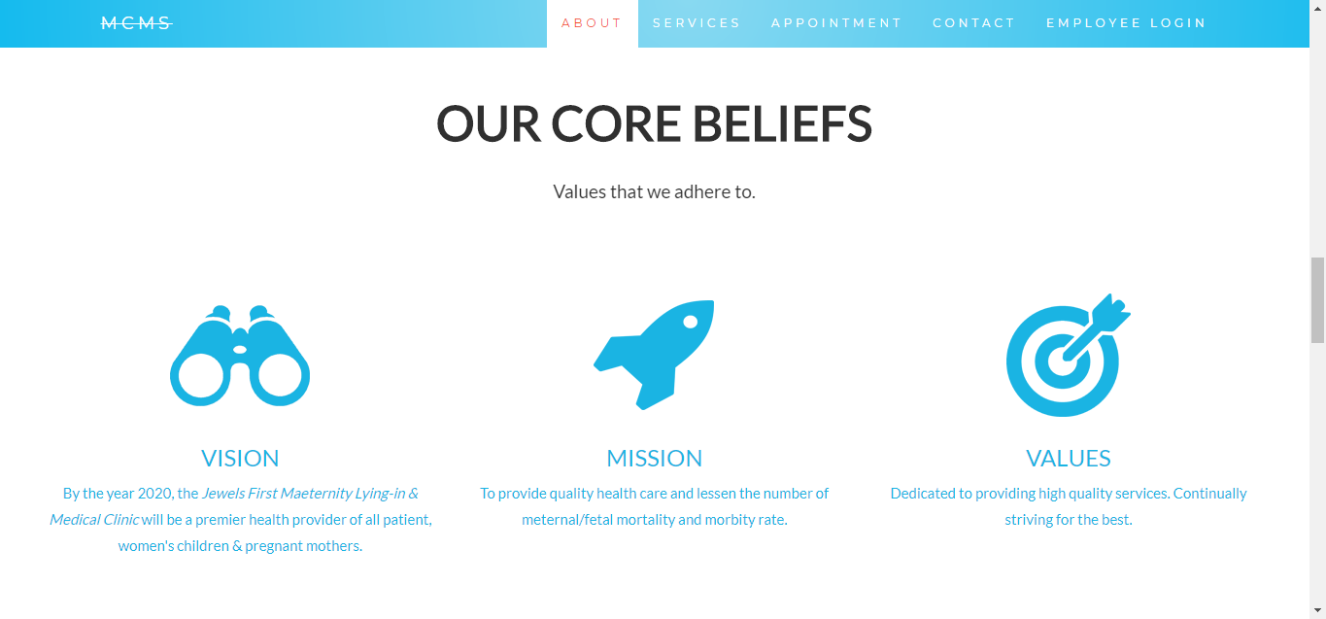

**Figure 10.3**

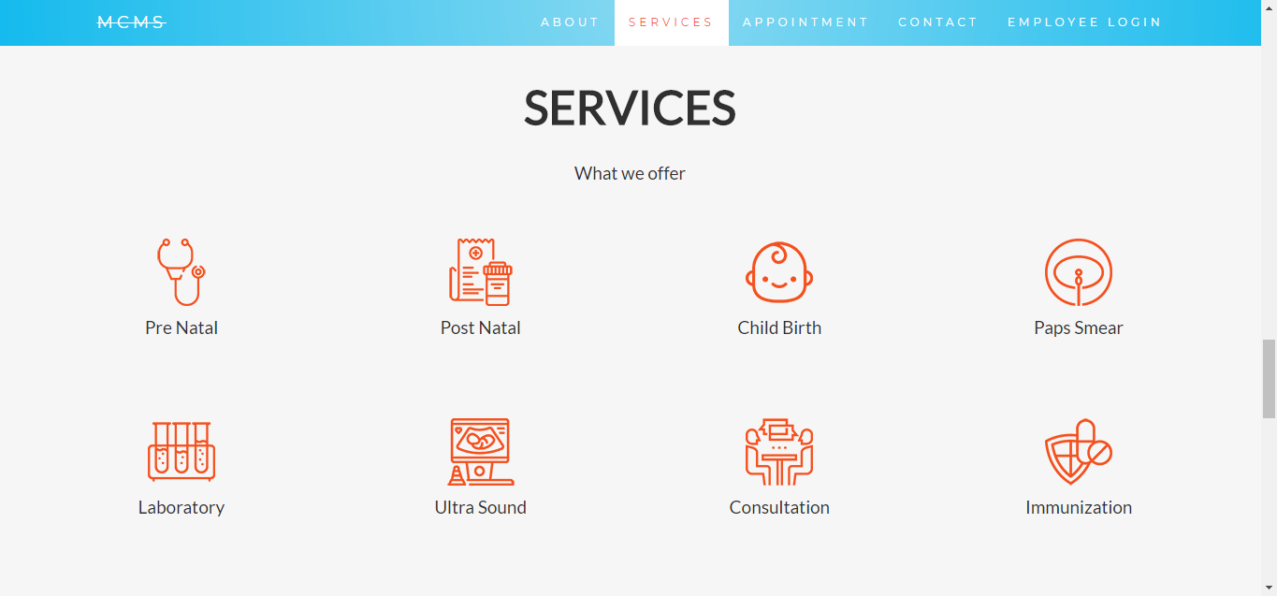

**Figure 10.4**

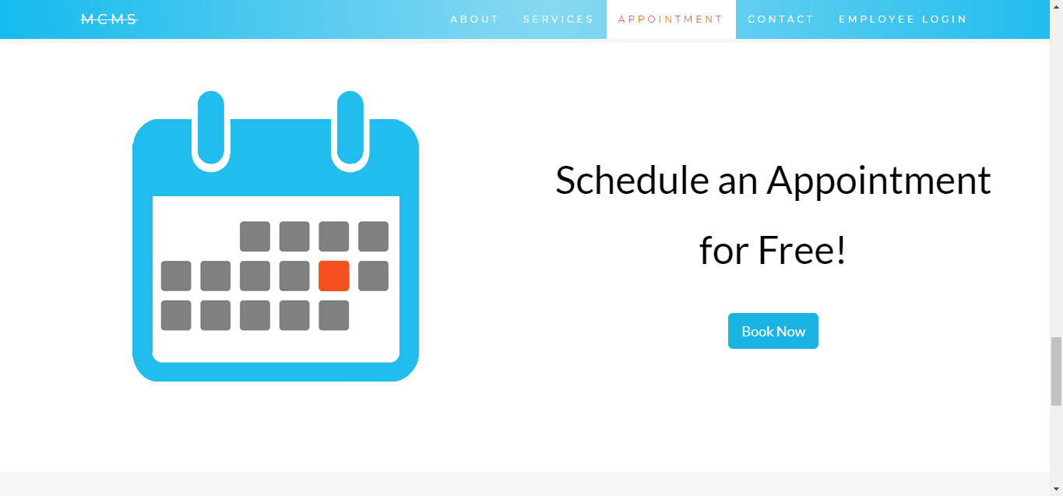

**Figure 10.5**

Figure 10.5 is where you can book an pointment that leads to Figure 12.

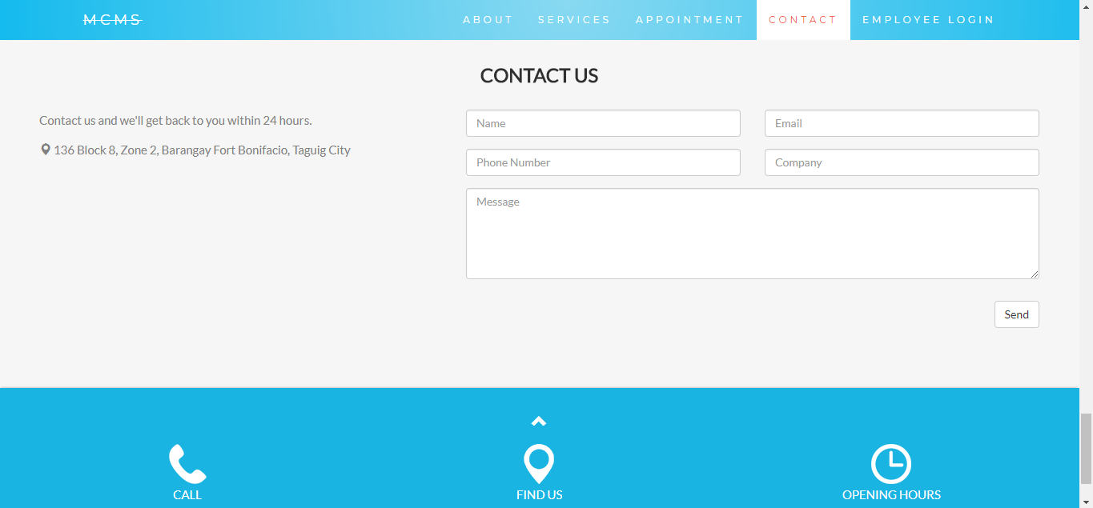

**Figure 10.6**

Figure 11 shows the whole webpage of Jewels First Maternity and Lying-in Clinic. Anyone can visit and view the Website.

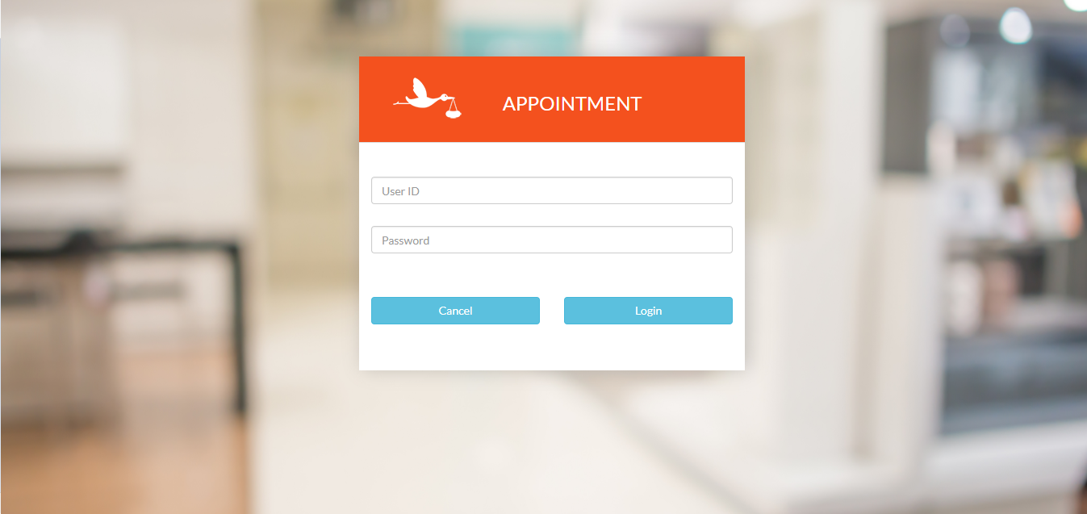

**Figure 11**

Figure 11 is the page where you can login as a existing patient and book for an appointment.

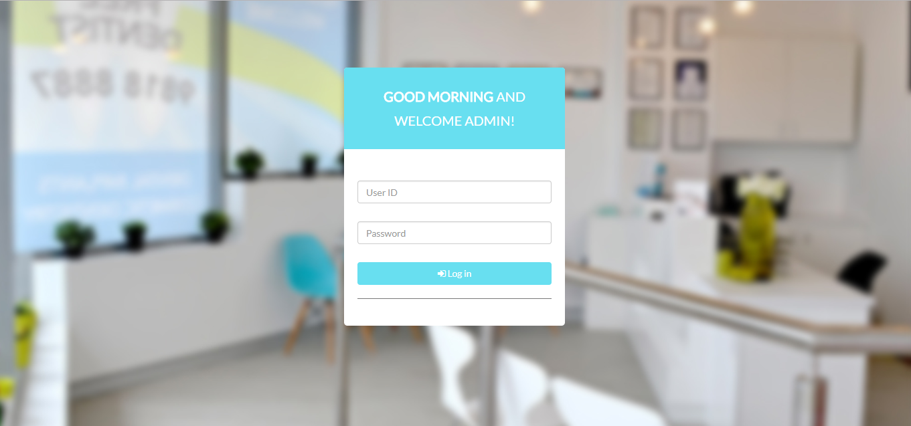

**Figure 12** Login Page

Figure 12 shows the login page for Admin. With correct user id and password the page will redirect you to Figure 15, Admin Dashboard.

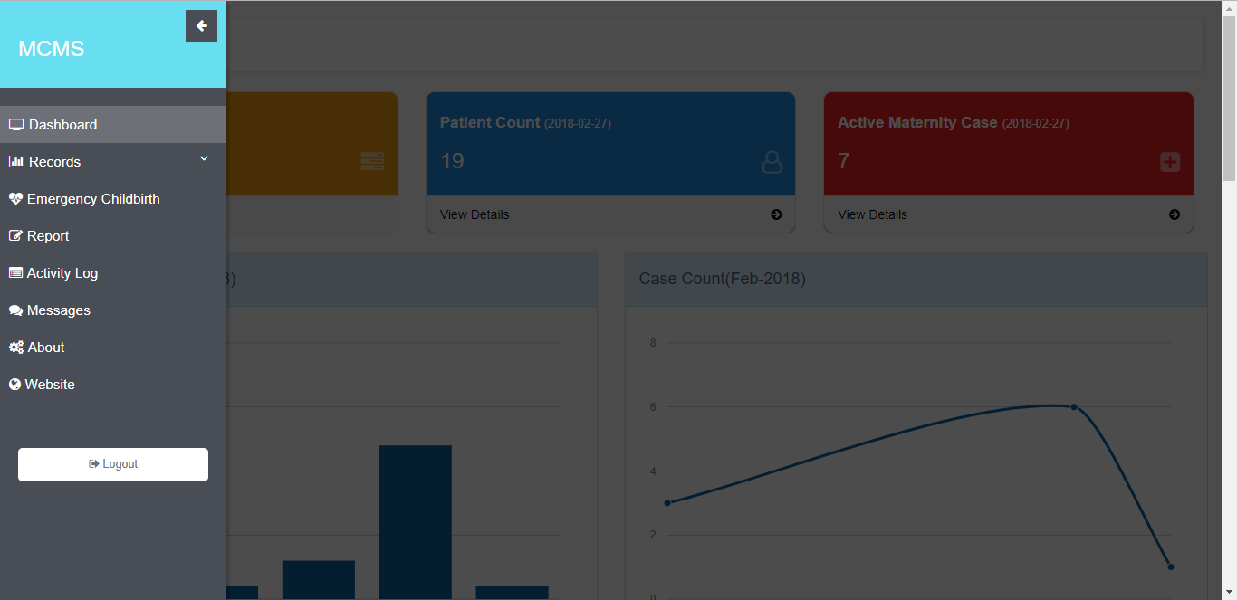

**Figure 13** Side Navigation Bar

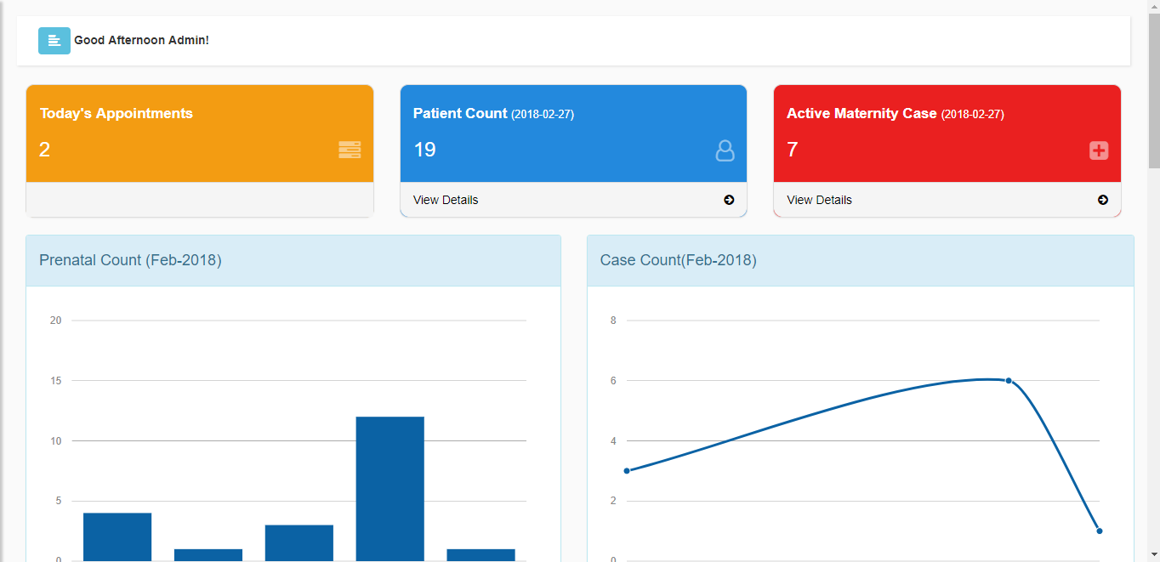

**Figure 14** Admin Dashboard

Figure 14 is where the admin can find all the recent activities and review all the patient cases along with basic information.

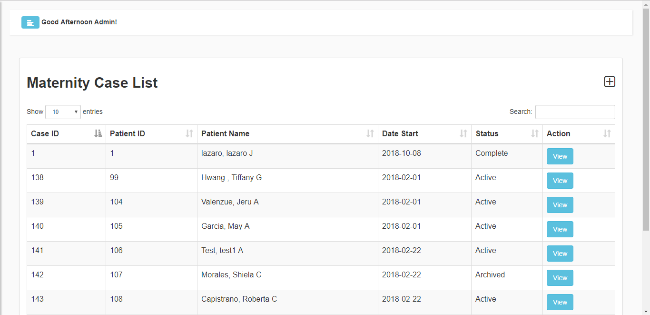

**Figure 15** Maternity Case List

Figure 15 shows the page consiting all the maternity cases of the clinic where you can also create new cases or update an existing account.

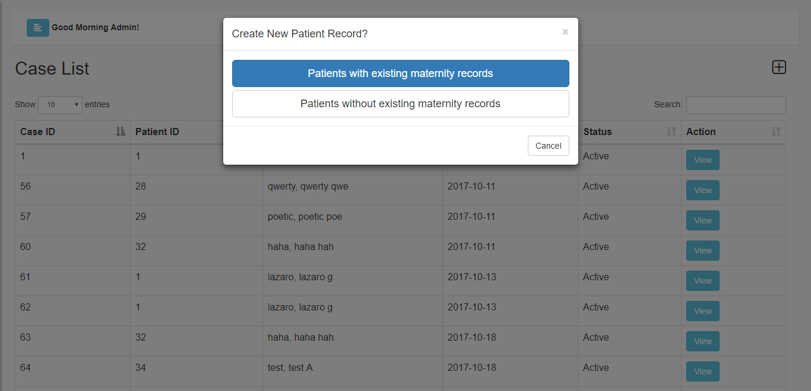

**Figure 16** Creating new cases

Figures 16 are the option of creating a new case or update.

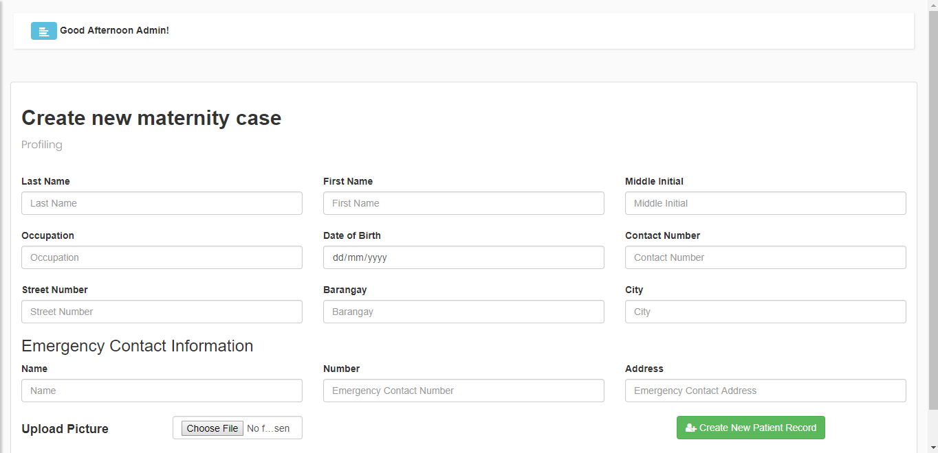

**Figure 17** Profiling

Figure 17 consisting of this page is the profiling for the new patient basic information for the pregnant woman and leads to filling up the physical examination and medical history, as shown in figure 19.

**Figure 20** Patient List

Figure 20 is the list of the patient and their profile that leads to Figure 21.

**Figure 21** Patient Profile

Figure 21 shows the profile of the patient, basic information and the whole timeline of her pregnancy.

**Figure 22** Infant List

As shown in Figure 22 this is where you can find all the infants and their information

**Figure 23** Report

Figure 23 is the example of generated PDF report of a chosen patient, all their information and laboratory results are included.

**Project Capabilities and Limitations**

The following are the capabilities of the developed system:

1. For data security, the system securely and confidentially keeping information of every individual/patient of the MCMS
2. The system provides the admin an automated Patient Record Management System
3. For existing patient they're able to book an appointment in the web page interface.
4. For billing, the system can easily generate a statement account for childbirth.
5. The system can also provide an overall record of chosen time frame format as PDF.

Just like any other systems, the system has the following limitations:

1. A non existing patient won't be able to book an appointment online.
2. Laboratory result are not provided by the Clinic
3. Recording labor information of patients, and centralizing the database of two clinic branches are not included in the system.

**Project Evaluation**

The system was evaluated by 50 evaluators, 5 are professionals whereas the other 45 are student within the Computer Association in this university.

**Test Results**

The system’s functional suitability evaluation result is shown in Table 12. 91.33% of the respondents rated with a score of 4 or “Highly Acceptable” and 8.67% rated with a score of 3 or “Very Acceptable” while 0% rated with a score of 2 or “Acceptable” and 1 or “Not Acceptable”.

Table 12. *Functional Suitability Evaluation Result*

|  |  |  |  |  |
| --- | --- | --- | --- | --- |
| **CRITERIA** | **4** | **3** | **2** | **1** |
| **Functional Suitability** |  |  |  |  |
| 1. Functional Completeness | 45 (90%) | 5 (10%) | 0 | 0 |
| 1. Functional Correctness | 46 (92%) | 4 (8%) | 0 | 0 |
| 1. Functional Appropriateness | 46 (92%) | 4 (8%) | 0 | 0 |
|  |  |  |  |  |
| **Overall Percentage** | **91.33%** | **8.67%** | **0%** | **0%** |

The system’s performance efficiency evaluation result is shown in Table 4. 84% of the respondents rated with a score of 4 or “Highly Acceptable” and 16% rated with a score of 3 or “Very Acceptable” while 0% rated with a score of 2 or “Acceptable” and 1 or “Not Acceptable”.

Table 4. *Performance Efficiency Evaluation Result*

|  |  |  |  |  |
| --- | --- | --- | --- | --- |
| **CRITERIA** | **4** | **3** | **2** | **1** |
| **Performance Efficiency** |  |  |  |  |
| 1. Time Behavior | 42 (84%) | 8 (16%) | 0 | 0 |
| 1. Resource Utilization | 40 (80%) | 10 (20%) | 0 | 0 |
| 1. Capacity | 44 (88%) | 6 (12%) | 0 | 0 |
|  |  |  |  |  |
| **Overall Percentage** | **84%** | **16%** | **0%** | **0%** |

The system’s compatibility evaluation result is shown in Table 5. 84% of the respondents rated with a score of 4 or “Highly Acceptable” and 16% rated with a score of 3 or “Very Acceptable” while 0% rated with a score of 2 or “Acceptable” and 1 or “Not Acceptable”.

Table 5. *Compatibility Evaluation Result*

|  |  |  |  |  |
| --- | --- | --- | --- | --- |
| **CRITERIA** | **4** | **3** | **2** | **1** |
| **Compatibility** |  |  |  |  |
| 1. Co-existence | 42 (84%) | 8 (16%) | 0 | 0 |
| 1. Interoperability | 42 (84%) | 8 (16%) | 0 | 0 |
|  |  |  |  |  |
| **Overall Percentage** | **84%** | **16%** | **0%** | **0%** |

The system’s usability evaluation result is shown in Table 6. 85.67% of the respondents rated with a score of 4 or “Highly Acceptable”, 13.67% rated with a score of 3 or “Very Acceptable”, and 0.67% rated with a score of 2 or “Acceptable” while 0% rated with a score of 1 or “Not Acceptable”.

Table 6. *Usability Evaluation Result*

|  |  |  |  |  |
| --- | --- | --- | --- | --- |
| **CRITERIA** | **4** | **3** | **2** | **1** |
| **Usability** |  |  |  |  |
| 1. Appropriateness Recognizability | 44 (88%) | 6 (12%) | 0 | 0 |
| 1. Learnability | 41 (82%) | 9 (18%) | 0 | 0 |
| 1. Operability | 43 (86%) | 6 (12%) | 1 (2%) | 0 |
| 1. User Error Protection | 42 (84%) | 7 (14%) | 1 (2%) | 0 |
| 1. User Interface Aesthetics | 42 (84%) | 8 (16%) | 0 | 0 |
| 1. Accessibility | 45 (90%) | 5 (10%) | 0 | 0 |
|  |  |  |  |  |
| **Overall Percentage** | **85.67%** | **13.67%** | **0.67%** | **0%** |

The system’s reliability evaluation result is shown in Table 7. 86.5% of the respondents rated with a score of 4 or “Highly Acceptable”, 13% rated with a score of 3 or “Very Acceptable”, and 0.5% rated with a score of 2 or “Acceptable” while 0% rated with a score of 1 or “Not Acceptable”.

Table 7. *Reliability Evaluation Result*

|  |  |  |  |  |
| --- | --- | --- | --- | --- |
| **CRITERIA** | **4** | **3** | **2** | **1** |
| **Reliability** |  |  |  |  |
| 1. Maturity | 47 (94%) | 2 (4%) | 1 (2%) | 0 |
| 1. Availability | 43 (86%) | 7 (14%) | 0 | 0 |
| 1. Fault Tolerance | 39 (78%) | 11 (22%) | 0 | 0 |
| 1. Recoverability | 44 (88%) | 6 (12%) | 0 | 0 |
|  |  |  |  |  |
| **Overall Percentage** | **86.5%** | **13%** | **0.5%** | **0%** |

The system’s security evaluation result is shown in Table 8. 88% of the respondents rated with a score of 4 or “Highly Acceptable”, 12% rated with a score of 3 or “Very Acceptable” while 0% rated with a score of 2 or “Acceptable” and 1 or “Not Acceptable”.

Table 8. *Security Evaluation Result*

|  |  |  |  |  |
| --- | --- | --- | --- | --- |
| **CRITERIA** | **4** | **3** | **2** | **1** |
| **Security** |  |  |  |  |
| 1. Confidentiality | 46 (92%) | 4 (8%) | 0 | 0 |
| 1. Integrity | 47 (94%) | 3 (6%) | 0 | 0 |
| 1. Non-repudiation | 42 (84%) | 8 (16%) | 0 | 0 |
| 1. Accountability | 42 (84%) | 8 (16%) | 0 | 0 |
| 1. Authenticity | 43 (86%) | 7 (14%) | 0 | 0 |
|  |  |  |  |  |
| **Overall Percentage** | **88%** | **12%** | **0%** | **0%** |

The system’s maintainability evaluation result is shown in Table 9. 85.6% of the respondents rated with a score of 4 or “Highly Acceptable”, 14.4% rated with a score of 3 or “Very Acceptable” while 0% rated with a score of 2 or “Acceptable” and 1 or “Not Acceptable”.

Table 9. *Maintainability Evaluation Result*

|  |  |  |  |  |
| --- | --- | --- | --- | --- |
| **CRITERIA** | **4** | **3** | **2** | **1** |
| **Maintainability** |  |  |  |  |
| 1. Modularity | 43 (86%) | 7 (14%) | 0 | 0 |
| 1. Reusability | 40 (80%) | 10 (20%) | 0 | 0 |
| 1. Analyzability | 46 (92%) | 4 (8%) | 0 | 0 |
| 1. Modifiability | 44 (88%) | 6 (12%) | 0 | 0 |
| 1. Testability | 41 (82%) | 9 (18%) | 0 | 0 |
|  |  |  |  |  |
| **Overall Percentage** | **85.6%** | **14.4%** | **0%** | **0%** |

The system’s portability evaluation result is shown in Table 10. 86% of the respondents rated with a score of 4 or “Highly Acceptable”, 14% rated with a score of 3 or “Very Acceptable” while 0% rated with a score of 2 or “Acceptable” and 1 or “Not Acceptable”.

Table 10. *Portability Evaluation Result*

|  |  |  |  |  |
| --- | --- | --- | --- | --- |
| **CRITERIA** | **4** | **3** | **2** | **1** |
| **Portability** |  |  |  |  |
| 1. Adaptability | 45 (90%) | 5 (10%) | 0 | 0 |
| 1. Installability | 40 (80%) | 10 (20%) | 0 | 0 |
| 1. Replaceability | 44 (88%) | 6 (12%) | 0 | 0 |
|  |  |  |  |  |
| **Overall Percentage** | **86%** | **14%** | **0%** | **0%** |

Table 11. *Overall Percentage Frequency of Evaluation Result*

|  |  |  |  |  |
| --- | --- | --- | --- | --- |
| **CRITERIA** | **4** | **3** | **2** | **1** |
| **Overall** |  |  |  |  |
| Functional Suitability | 91.33% | 8.67% | 0 | 0 |
| Performance Efficiency | 84% | 16% | 0 | 0 |
| Compatibility | 84% | 16% | 0 | 0 |
| Usability | 85.67% | 13.67% | 0.67% | 0 |
| Reliability | 86.5% | 13% | 0.5% | 0 |
| Security | 88% | 12% | 0 | 0 |
| Maintainability | 85.6% | 14.4% | 0 | 0 |
| Portability | 86% | 4% | 0 | 0 |
|  |  |  |  |  |
| **Overall Percentage Frequency** | **86.39%** | **12.22%** | **0.15%** | **0** |

Overall, the system was rated with a score of 4 or “Highly Acceptable” by the 86.39% of all the respondents from each of the criterion. 12.22% of the respondents rated the system with a score of 3 or “Very Acceptable”.

**Chapter 5**

**SUMMARY OF FINDINGS, CONCLUSIONS AND RECOMMENDATIONS**

This chapter contains the summary of findings, conclusions and recommendations derived to further improve the system.

**Summary of Findings**

The developed system was able to: (1) web based appointment booking (2) manage reports of physical examination and medical history(3) automatically generate statement of account and (4) effectively manage and store records regarding MCMS.

The researchers did found 50 people to evaluate the acceptability of the system. Those 50 people composed of 3 professionals and 47 students within the Computer Association in this university. The findings of the evaluation are the following:

1. 91.33% of the respondents considers the system’s functional suitability are highly acceptable which means that the functions of the system were complete, correct, and appropriate for the needs of the end-users.
2. 84% of the respondents were amazed with the system’s performance efficiency and gave a score of 4 or “Highly Acceptable”.
3. The compatibility criterion garnered a highly acceptable score from 84% of the respondents which means that the system can co-exist with other products and is interoperable.
4. 85.67% of the respondents were impressed with the system’s usability thus giving in a mark of highly acceptable.
5. The system’s reliability is highly acceptable according to 86.5% of the respondents.
6. According to 88% of the respondents, the system’s security is highly acceptable.
7. The system garnered a highly acceptable mark from 85.6% of the respondents which means that the system is reusable and modifiable.
8. The portability criterion were marked highly acceptable by 86% of the respondents which mean that the system can adapt to changes in SPMS.

86.39% of the evaluators have given the system a score of 4 in each criterion which can be interpreted as “Highly Acceptable”.

**Conclusions**

The following conclusions were drawn from this study:

1. Web-based of Jewel’s Maternity and Lying in Medical Clinic was successfully designed by having the following features:
   1. Jewel’s Maternity and Lying-in Clinic inquiry website.
   2. Electronically process of profiling patient to facilitate paperless forms.
   3. Online appointment
   4. Generated statement of account.
   5. Over all report as PDF
   6. Centralized information for easy access of any information.
2. The system was created using CodeIgniter (PHP framework), Bootstrap (HTML, CSS, and JavaScript framework), XAMPP (Cross-Platform Apache, Maria DB, PHP, and Perl) server, MySQL Workbench, Atom text editor, and Google Chrome web browser.
3. The system was tested and improved in terms of functionality, accuracy, and security.
4. The system was evaluated using ISO 25010 as quality model metrics with a percentage frequency of 86.39% as “Highly Acceptable”.

**Recommendations**

. The following are the researchers own recommendations for the study:

1. The system should have an e-mailing or mobile texting module for alerts regarding SPMS announcements.
2. A mobile application for a more accessible use of the system.
3. Uploading of files and reports for accomplishment verification.

**Appendix A**

**GANTT CHART**

**DEVELOPMENT OF A STRATEGIC PERFORMANCE MANAGEMENT INFORMATION SYSTEM**

|  |  |  |  |  |  |  |  |  |  |  |  |  |  |  |  |  |  |  |  |  |  |  |  |  |  |
| --- | --- | --- | --- | --- | --- | --- | --- | --- | --- | --- | --- | --- | --- | --- | --- | --- | --- | --- | --- | --- | --- | --- | --- | --- | --- |
| Stages/Month of Implementation | **SEPTEMBER** | | | | | **OCTOBER** | | | | | **NOVEMBER** | | | | | **DECEMBER** | | | | | **JANUARY** | | | | |
| Week No. | **1** | **2** | **3** | **4** | **5** | **1** | **2** | **3** | **4** | **5** | **1** | **2** | **3** | **4** | **5** | **1** | **2** | **3** | **4** | **5** | **1** | **2** | **3** | **4** | **5** |
| Documentation Chapters 1, 2, 3 |  |  |  |  |  |  |  |  |  |  |  |  |  |  |  |  |  |  |  |  |  |  |  |  |  |
| Database Management |  |  |  |  |  |  |  |  |  |  |  |  |  |  |  |  |  |  |  |  |  |  |  |  |  |
| Login Module |  |  |  |  |  |  |  |  |  |  |  |  |  |  |  |  |  |  |  |  |  |  |  |  |  |
| Dashboard Module |  |  |  |  |  |  |  |  |  |  |  |  |  |  |  |  |  |  |  |  |  |  |  |  |  |
| Patient and infants Module |  |  |  |  |  |  |  |  |  |  |  |  |  |  |  |  |  |  |  |  |  |  |  |  |  |
| Admin Module |  |  |  |  |  |  |  |  |  |  |  |  |  |  |  |  |  |  |  |  |  |  |  |  |  |
| Report Module |  |  |  |  |  |  |  |  |  |  |  |  |  |  |  |  |  |  |  |  |  |  |  |  |  |
| Testing and Debugging |  |  |  |  |  |  |  |  |  |  |  |  |  |  |  |  |  |  |  |  |  |  |  |  |  |
| Evaluation and Implementation |  |  |  |  |  |  |  |  |  |  |  |  |  |  |  |  |  |  |  |  |  |  |  |  |  |
| Documentation Chapters 4 & 5 |  |  |  |  |  |  |  |  |  |  |  |  |  |  |  |  |  |  |  |  |  |  |  |  |  |

**Appendix B**

**TUP SPMIS EVALUATION FORM**

Technological University of the Philippines  
College of Science  
Ayala Blvd., Ermita, Manila

Name (optional):

☐ Professional ☐ Student

**Direction**: Based on the criteria presented, rate the system from 1 (lowest) to 4 (highest) by means of checking the box under the rating per criteria.

|  |  |  |  |  |
| --- | --- | --- | --- | --- |
| **CRITERIA** | **RATING** | | | |
|  | **1** | **2** | **3** | **4** |
| **FUNCTIONAL SUITABILITY** |  |  |  |  |
| 1. FUNCTIONAL COMPLETENESS: Degree to which the set of functions covers all the specified tasks and user objectives. |  |  |  |  |
| 1. FUNCTIONAL CORRECTNESS: Degree to which a product or system provides the correct results with the needed degree of precision. |  |  |  |  |
| 1. FUNCTIONAL APPROPRIATENESS: Degree to which the functions facilitate the accomplishment of specified tasks and objectives. |  |  |  |  |
| **PERFORMANCE EFFICIENCY** |  |  |  |  |
| 1. TIME BEHAVIOUR: Degree to which the response and processing times and throughput rates of a product or system, when performing its functions, meet requirements. |  |  |  |  |
| 1. RESOURSE UTILIZATION: Degree to which the amounts and types of resources used by a product or system, when performing its functions, meet requirements. |  |  |  |  |
| 1. CAPACITY: Degree to which the maximum limits of a product or system parameter meet requirements. |  |  |  |  |
| **COMPATIBILITY** |  |  |  |  |
| 1. CO-EXISTENCE: Degree to which a product can perform its required functions efficiently while sharing a common environment and resources with other products, without detrimental impact on any other product. |  |  |  |  |
| 1. INTEROPERABILITY: Degree to which two or more systems, products or components can exchange information and use the information that has been exchanged. |  |  |  |  |
| **USABILITY** |  |  |  |  |
| 1. APPROPRIATENESS RECOGNIZABILITY: Degree to which users can recognize whether a product or system is appropriate for their needs. |  |  |  |  |
| 1. LEARNABILITY: Degree to which a product or system can be used by specified users to achieve specified goals of learning to use the product or system with effectiveness, efficiency, freedom from risk and satisfaction in a specified context of use. |  |  |  |  |
| 1. OPERABILITY: Degree to which a product or system has attributes that make it easy to operate and control. |  |  |  |  |
| 1. USER ERROR PROTECTION: Degree to which a system protects users against making errors. |  |  |  |  |
| 1. USER INTERFACE AESTHETICS: Degree to which a user interface enables pleasing and satisfying interaction for the user. |  |  |  |  |
| 1. ACCESSIBILITY: Degree to which a product or system can be used by people with the widest range of characteristics and capabilities to achieve a specified goal in a specified context of use. |  |  |  |  |
| **RELIABILITY** |  |  |  |  |
| 1. MATURITY: Degree to which a system, product or component meets needs for reliability under normal operation. |  |  |  |  |
| 1. AVAILABILITY: Degree to which a system, product or component is operational and accessible when required for use. |  |  |  |  |
| 1. FAULT TOLERANCE: Degree to which a system, product or component operates as intended despite the presence of hardware or software faults. |  |  |  |  |
| 1. RECOVERABILTY: Degree to which, in the event of an interruption or a failure, a product or system can recover the data directly affected and re-establish the desired state of the system. |  |  |  |  |
| **SECURITY** |  |  |  |  |
| 1. CONFIDENTIALITY: Degree to which a product or system ensures that data are accessible only to those authorized to have access. |  |  |  |  |
| 1. INTEGRITY: Degree to which a system, product or component prevents unauthorized access to, or modification of, computer programs or data. |  |  |  |  |
| 1. NON-REPUDIATION: Degree to which actions or events can be proven to have taken place, so that the events or actions cannot be repudiated later. |  |  |  |  |
| 1. ACCOUNTABILITY: Degree to which the actions of an entity can be traced uniquely to the entity. |  |  |  |  |
| 1. AUTHENTICITY: Degree to which the identity of a subject or resource can be proved to be the one claimed. |  |  |  |  |
| **MAINTAINABILITY** |  |  |  |  |
| 1. MODULARITY: Degree to which a system or computer program is composed of discrete components such that a change to one component has minimal impact on other components. |  |  |  |  |
| 1. REUSABILITY: Degree to which an asset can be used in more than one system, or in building other assets. |  |  |  |  |
| 1. ANALYSABILITY: Degree of effectiveness and efficiency with which it is possible to assess the impact on a product or system of an intended change to one or more of its parts, or to diagnose a product for deficiencies or causes of failures, or to identify parts to be modified. |  |  |  |  |
| 1. MODIFIABILITY: Degree to which a product or system can be effectively and efficiently modified without introducing defects or degrading existing product quality. |  |  |  |  |
| 1. TESTABILITY: Degree of effectiveness and efficiency with which test criteria can be established for a system, product or component and tests can be performed to determine whether those criteria have been met. |  |  |  |  |
| **PORTABILITY** |  |  |  |  |
| 1. ADAPTABILITY: Degree to which a product or system can effectively and efficiently be adapted for different or evolving hardware, software or other operational or usage environments. |  |  |  |  |
| 1. INSTALLABILITY: Degree of effectiveness and efficiency with which a product or system can be successfully installed and/or uninstalled in a specified environment. |  |  |  |  |
| 1. REPLACEABILITY: Degree to which a product can replace another specified software product for the same purpose in the same environment. |  |  |  |  |

**Comments/Suggestions:**

**Appendix C**

**TABULATION TABLE**

|  |  |  |  |  |  |  |  |  |  |  |  |  |  |  |  |  |  |  |  |  |  |  |  |  |  |  |  |  |  |  |  |
| --- | --- | --- | --- | --- | --- | --- | --- | --- | --- | --- | --- | --- | --- | --- | --- | --- | --- | --- | --- | --- | --- | --- | --- | --- | --- | --- | --- | --- | --- | --- | --- |
|  | Functional Suitability | | | Performance Efficiency | | | Compatibility | | Usability | | | | | | Reliability | | | | Security | | | | | Maintainability | | | | | Portability | | |
| Evaluator | 1 | 2 | 3 | 1 | 2 | 3 | 1 | 2 | 1 | 2 | 3 | 4 | 5 | 6 | 1 | 2 | 3 | 4 | 1 | 2 | 3 | 4 | 5 | 1 | 2 | 3 | 4 | 5 | 1 | 2 | 3 |
| 1 | 4 | 4 | 4 | 4 | 3 | 4 | 4 | 4 | 3 | 4 | 4 | 4 | 4 | 4 | 4 | 4 | 4 | 4 | 4 | 4 | 4 | 4 | 4 | 3 | 4 | 4 | 4 | 4 | 3 | 3 | 3 |
| 2 | 3 | 3 | 3 | 4 | 4 | 4 | 3 | 4 | 4 | 3 | 3 | 4 | 4 | 4 | 4 | 4 | 4 | 4 | 4 | 4 | 4 | 4 | 4 | 3 | 3 | 3 | 3 | 3 | 4 | 4 | 4 |
| 3 | 4 | 4 | 4 | 4 | 3 | 4 | 4 | 4 | 4 | 4 | 4 | 4 | 4 | 4 | 4 | 4 | 4 | 4 | 4 | 4 | 4 | 4 | 4 | 4 | 4 | 4 | 4 | 3 | 4 | 3 | 3 |
| 4 | 4 | 4 | 4 | 4 | 3 | 4 | 4 | 4 | 4 | 4 | 4 | 4 | 4 | 4 | 4 | 4 | 4 | 4 | 4 | 4 | 4 | 4 | 4 | 4 | 4 | 4 | 4 | 3 | 4 | 3 | 3 |
| 5 | 4 | 4 | 4 | 4 | 4 | 3 | 4 | 3 | 4 | 4 | 4 | 3 | 3 | 4 | 4 | 3 | 3 | 3 | 4 | 4 | 3 | 3 | 3 | 4 | 4 | 4 | 4 | 4 | 4 | 4 | 4 |
| 6 | 4 | 4 | 4 | 4 | 4 | 4 | 4 | 4 | 4 | 4 | 4 | 4 | 4 | 4 | 4 | 4 | 4 | 4 | 4 | 4 | 4 | 4 | 4 | 4 | 4 | 4 | 4 | 4 | 4 | 4 | 4 |
| 7 | 4 | 4 | 4 | 4 | 4 | 4 | 4 | 4 | 4 | 3 | 3 | 4 | 4 | 4 | 4 | 4 | 3 | 4 | 4 | 4 | 4 | 4 | 4 | 4 | 3 | 4 | 3 | 4 | 3 | 4 | 4 |
| 8 | 4 | 4 | 4 | 4 | 4 | 4 | 4 | 3 | 4 | 4 | 4 | 4 | 4 | 4 | 4 | 4 | 4 | 4 | 4 | 4 | 4 | 4 | 4 | 4 | 4 | 4 | 4 | 4 | 4 | 4 | 4 |
| 9 | 4 | 4 | 3 | 3 | 4 | 3 | 4 | 4 | 4 | 3 | 2 | 4 | 4 | 4 | 4 | 3 | 4 | 3 | 4 | 3 | 4 | 3 | 3 | 4 | 4 | 4 | 3 | 3 | 4 | 4 | 3 |
| 10 | 4 | 3 | 4 | 3 | 4 | 4 | 4 | 4 | 4 | 3 | 4 | 4 | 3 | 4 | 4 | 3 | 3 | 4 | 4 | 3 | 4 | 3 | 4 | 4 | 3 | 4 | 4 | 3 | 3 | 4 | 4 |
| 11 | 3 | 4 | 4 | 4 | 4 | 4 | 4 | 4 | 4 | 4 | 3 | 4 | 4 | 4 | 4 | 4 | 4 | 4 | 4 | 4 | 4 | 4 | 4 | 4 | 4 | 4 | 4 | 4 | 4 | 4 | 4 |
| 12 | 4 | 4 | 4 | 4 | 4 | 4 | 4 | 4 | 4 | 4 | 4 | 4 | 4 | 4 | 4 | 4 | 4 | 4 | 4 | 4 | 4 | 4 | 4 | 4 | 4 | 4 | 4 | 4 | 4 | 4 | 4 |
| 13 | 4 | 4 | 4 | 4 | 4 | 4 | 4 | 4 | 4 | 4 | 4 | 4 | 4 | 4 | 4 | 4 | 4 | 4 | 4 | 4 | 4 | 4 | 4 | 4 | 4 | 4 | 4 | 4 | 4 | 4 | 4 |
| 14 | 4 | 4 | 4 | 4 | 4 | 4 | 4 | 4 | 4 | 4 | 4 | 4 | 4 | 4 | 4 | 4 | 4 | 4 | 4 | 4 | 4 | 4 | 4 | 4 | 4 | 4 | 4 | 4 | 4 | 4 | 4 |
| 15 | 4 | 4 | 4 | 3 | 3 | 4 | 4 | 3 | 4 | 4 | 3 | 3 | 4 | 4 | 4 | 4 | 3 | 4 | 3 | 4 | 3 | 3 | 3 | 4 | 3 | 3 | 3 | 4 | 3 | 3 | 4 |
| 16 | 4 | 4 | 4 | 4 | 3 | 4 | 4 | 4 | 3 | 3 | 4 | 4 | 4 | 3 | 4 | 4 | 4 | 4 | 3 | 4 | 4 | 4 | 3 | 4 | 3 | 4 | 4 | 3 | 4 | 4 | 4 |
| 17 | 4 | 4 | 4 | 4 | 4 | 4 | 4 | 4 | 4 | 4 | 4 | 4 | 4 | 4 | 4 | 4 | 4 | 4 | 4 | 4 | 4 | 4 | 4 | 4 | 4 | 4 | 4 | 4 | 4 | 4 | 4 |
| 18 | 4 | 4 | 4 | 4 | 4 | 4 | 4 | 4 | 4 | 4 | 4 | 4 | 4 | 4 | 4 | 4 | 4 | 4 | 4 | 4 | 4 | 4 | 4 | 4 | 4 | 4 | 4 | 4 | 4 | 4 | 4 |
| 19 | 4 | 4 | 4 | 3 | 4 | 4 | 3 | 4 | 4 | 3 | 3 | 4 | 3 | 3 | 4 | 3 | 3 | 4 | 4 | 4 | 4 | 3 | 4 | 3 | 3 | 4 | 4 | 4 | 4 | 4 | 4 |
| 20 | 4 | 3 | 4 | 3 | 4 | 4 | 3 | 3 | 4 | 4 | 4 | 3 | 4 | 4 | 4 | 3 | 4 | 3 | 4 | 4 | 3 | 4 | 3 | 3 | 4 | 4 | 4 | 3 | 3 | 4 | 4 |
| 21 | 3 | 4 | 4 | 4 | 3 | 3 | 3 | 3 | 4 | 4 | 4 | 2 | 3 | 4 | 2 | 4 | 3 | 4 | 4 | 4 | 3 | 3 | 3 | 4 | 3 | 3 | 3 | 4 | 4 | 4 | 4 |
| 22 | 4 | 4 | 4 | 4 | 4 | 4 | 4 | 4 | 3 | 4 | 4 | 4 | 4 | 4 | 4 | 4 | 4 | 4 | 3 | 4 | 4 | 4 | 4 | 4 | 3 | 4 | 4 | 4 | 4 | 4 | 4 |
| 23 | 4 | 4 | 4 | 3 | 4 | 3 | 4 | 4 | 4 | 4 | 4 | 4 | 4 | 3 | 4 | 4 | 4 | 3 | 4 | 4 | 4 | 3 | 4 | 4 | 4 | 4 | 4 | 4 | 4 | 3 | 4 |
| 24 | 4 | 3 | 4 | 4 | 4 | 4 | 3 | 3 | 4 | 4 | 4 | 3 | 3 | 4 | 4 | 4 | 4 | 4 | 4 | 4 | 3 | 4 | 4 | 3 | 4 | 4 | 4 | 3 | 4 | 4 | 4 |
| 25 | 3 | 3 | 3 | 3 | 4 | 4 | 3 | 4 | 3 | 3 | 4 | 4 | 3 | 3 | 3 | 3 | 3 | 4 | 4 | 4 | 3 | 3 | 4 | 3 | 4 | 4 | 3 | 4 | 4 | 3 | 3 |

|  |  |  |  |  |  |  |  |  |  |  |  |  |  |  |  |  |  |  |  |  |  |  |  |  |  |  |  |  |  |  |  |
| --- | --- | --- | --- | --- | --- | --- | --- | --- | --- | --- | --- | --- | --- | --- | --- | --- | --- | --- | --- | --- | --- | --- | --- | --- | --- | --- | --- | --- | --- | --- | --- |
| 26 | 3 | 4 | 4 | 4 | 4 | 3 | 3 | 4 | 3 | 4 | 4 | 4 | 3 | 4 | 3 | 4 | 3 | 4 | 4 | 4 | 3 | 4 | 3 | 4 | 4 | 3 | 4 | 4 | 4 | 3 | 4 |
| 27 | 4 | 4 | 4 | 3 | 4 | 4 | 4 | 4 | 4 | 4 | 4 | 3 | 4 | 4 | 4 | 4 | 3 | 3 | 4 | 4 | 4 | 4 | 4 | 4 | 4 | 4 | 4 | 4 | 4 | 3 | 4 |
| 28 | 4 | 4 | 4 | 4 | 4 | 4 | 4 | 3 | 4 | 4 | 4 | 4 | 4 | 4 | 4 | 4 | 4 | 4 | 4 | 4 | 4 | 4 | 4 | 4 | 4 | 4 | 4 | 4 | 4 | 4 | 4 |
| 29 | 4 | 4 | 4 | 4 | 4 | 4 | 4 | 4 | 4 | 4 | 4 | 4 | 4 | 4 | 4 | 4 | 4 | 4 | 4 | 3 | 4 | 4 | 4 | 4 | 4 | 4 | 4 | 4 | 4 | 4 | 4 |
| 30 | 4 | 4 | 4 | 4 | 4 | 4 | 4 | 4 | 4 | 4 | 3 | 4 | 4 | 4 | 4 | 4 | 4 | 4 | 3 | 4 | 4 | 4 | 4 | 4 | 4 | 4 | 4 | 4 | 4 | 4 | 4 |
| 31 | 4 | 4 | 4 | 4 | 4 | 4 | 4 | 4 | 4 | 4 | 4 | 4 | 4 | 4 | 4 | 4 | 4 | 4 | 4 | 4 | 4 | 4 | 4 | 4 | 4 | 4 | 4 | 4 | 4 | 4 | 4 |
| 32 | 4 | 4 | 4 | 4 | 4 | 4 | 4 | 4 | 4 | 4 | 4 | 4 | 4 | 4 | 4 | 4 | 4 | 4 | 4 | 4 | 4 | 4 | 4 | 4 | 4 | 4 | 4 | 4 | 4 | 4 | 4 |
| 33 | 4 | 4 | 4 | 4 | 4 | 4 | 4 | 4 | 4 | 4 | 4 | 4 | 4 | 4 | 4 | 4 | 4 | 4 | 4 | 4 | 4 | 4 | 4 | 4 | 4 | 4 | 4 | 4 | 4 | 4 | 4 |
| 34 | 4 | 4 | 4 | 4 | 4 | 4 | 4 | 4 | 4 | 4 | 4 | 4 | 4 | 4 | 4 | 4 | 4 | 4 | 4 | 4 | 4 | 4 | 4 | 4 | 4 | 4 | 4 | 4 | 4 | 4 | 4 |
| 35 | 4 | 4 | 4 | 4 | 3 | 3 | 4 | 4 | 4 | 3 | 4 | 4 | 4 | 3 | 4 | 3 | 3 | 4 | 4 | 4 | 4 | 4 | 4 | 4 | 4 | 4 | 4 | 4 | 4 | 4 | 4 |
| 36 | 4 | 4 | 4 | 4 | 4 | 4 | 4 | 4 | 4 | 4 | 4 | 4 | 4 | 4 | 4 | 4 | 4 | 4 | 4 | 4 | 4 | 4 | 4 | 4 | 4 | 4 | 4 | 4 | 4 | 4 | 4 |
| 37 | 4 | 4 | 4 | 4 | 3 | 4 | 4 | 4 | 4 | 4 | 4 | 3 | 4 | 4 | 4 | 4 | 4 | 3 | 4 | 4 | 4 | 4 | 4 | 4 | 3 | 4 | 4 | 4 | 4 | 3 | 4 |
| 38 | 4 | 4 | 4 | 4 | 4 | 4 | 4 | 4 | 4 | 4 | 4 | 4 | 4 | 4 | 4 | 4 | 4 | 4 | 4 | 4 | 4 | 4 | 4 | 4 | 4 | 4 | 4 | 4 | 4 | 4 | 4 |
| 39 | 4 | 4 | 4 | 4 | 4 | 4 | 4 | 4 | 4 | 4 | 4 | 4 | 4 | 4 | 4 | 4 | 4 | 4 | 4 | 4 | 4 | 4 | 4 | 4 | 4 | 4 | 4 | 4 | 4 | 4 | 4 |
| 40 | 4 | 4 | 4 | 4 | 4 | 4 | 3 | 4 | 4 | 4 | 4 | 4 | 4 | 4 | 4 | 4 | 4 | 4 | 4 | 4 | 4 | 3 | 4 | 4 | 4 | 4 | 4 | 4 | 4 | 4 | 4 |
| 41 | 4 | 4 | 4 | 4 | 4 | 4 | 4 | 4 | 4 | 4 | 4 | 4 | 4 | 4 | 4 | 4 | 4 | 4 | 4 | 4 | 4 | 4 | 4 | 4 | 4 | 4 | 4 | 4 | 4 | 4 | 4 |
| 42 | 4 | 4 | 4 | 4 | 4 | 4 | 4 | 4 | 4 | 4 | 4 | 4 | 4 | 4 | 4 | 4 | 4 | 4 | 4 | 4 | 4 | 4 | 4 | 4 | 4 | 4 | 4 | 4 | 4 | 4 | 4 |
| 43 | 4 | 4 | 4 | 4 | 4 | 4 | 4 | 4 | 4 | 4 | 4 | 4 | 4 | 4 | 4 | 4 | 4 | 4 | 4 | 4 | 4 | 4 | 4 | 4 | 4 | 4 | 4 | 4 | 4 | 4 | 4 |
| 44 | 4 | 4 | 4 | 4 | 4 | 4 | 4 | 4 | 4 | 4 | 4 | 4 | 4 | 4 | 4 | 4 | 4 | 4 | 4 | 4 | 4 | 4 | 4 | 4 | 3 | 4 | 4 | 3 | 4 | 3 | 4 |
| 45 | 4 | 4 | 4 | 4 | 4 | 4 | 4 | 4 | 4 | 3 | 4 | 4 | 4 | 4 | 4 | 4 | 4 | 4 | 4 | 4 | 4 | 4 | 4 | 4 | 4 | 4 | 4 | 4 | 4 | 4 | 4 |
| 46 | 4 | 4 | 4 | 4 | 3 | 4 | 4 | 3 | 4 | 4 | 4 | 4 | 3 | 4 | 4 | 4 | 4 | 4 | 4 | 4 | 4 | 4 | 4 | 3 | 4 | 4 | 4 | 4 | 4 | 4 | 4 |
| 47 | 4 | 4 | 4 | 4 | 4 | 4 | 4 | 4 | 3 | 4 | 4 | 3 | 4 | 4 | 4 | 4 | 3 | 4 | 4 | 4 | 4 | 4 | 4 | 4 | 4 | 4 | 4 | 4 | 4 | 4 | 3 |
| 48 | 4 | 4 | 4 | 4 | 4 | 4 | 4 | 4 | 4 | 4 | 4 | 4 | 4 | 4 | 4 | 4 | 4 | 4 | 4 | 4 | 4 | 4 | 4 | 4 | 4 | 4 | 4 | 4 | 4 | 4 | 4 |
| 49 | 4 | 4 | 4 | 4 | 4 | 4 | 4 | 4 | 4 | 4 | 4 | 4 | 4 | 4 | 4 | 4 | 4 | 4 | 4 | 4 | 4 | 4 | 4 | 4 | 4 | 4 | 4 | 4 | 4 | 4 | 4 |
| 50 | 4 | 4 | 4 | 4 | 4 | 4 | 4 | 4 | 4 | 4 | 4 | 4 | 4 | 4 | 4 | 4 | 4 | 4 | 4 | 4 | 4 | 4 | 4 | 4 | 4 | 4 | 4 | 4 | 4 | 4 | 4 |
| Frequency | 4 | 4 | 4 | 4 | 4 | 4 | 4 | 4 | 4 | 4 | 4 | 4 | 4 | 4 | 4 | 4 | 4 | 4 | 4 | 4 | 4 | 4 | 4 | 4 | 4 | 4 | 4 | 4 | 4 | 4 | 4 |
| Overall Frequency | 4 | | | | | | | | | | | | | | | | | | | | | | | | | | | | | | |
| Overall Descriptive Rating | Highly Acceptable | | | | | | | | | | | | | | | | | | | | | | | | | | | | | | |